1. Install Eclipse

Install eclipse and install egit plugin

Step1: Install eclipse Installer from google

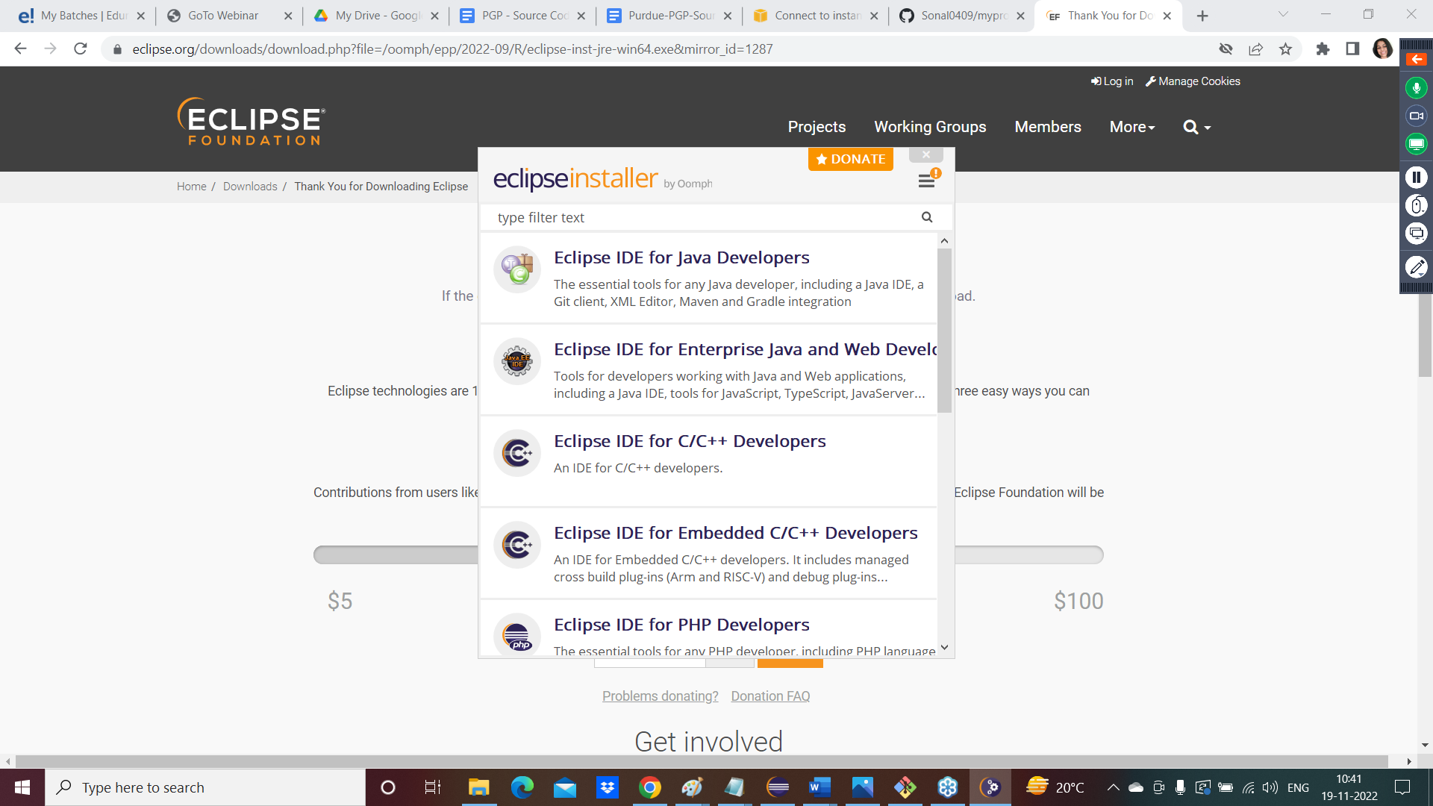

Click on Eclipse IDE for java Developers

Eclipse will be installed, and you can see it on your desktop

Double click on eclipse icon and open it

Click on launch button

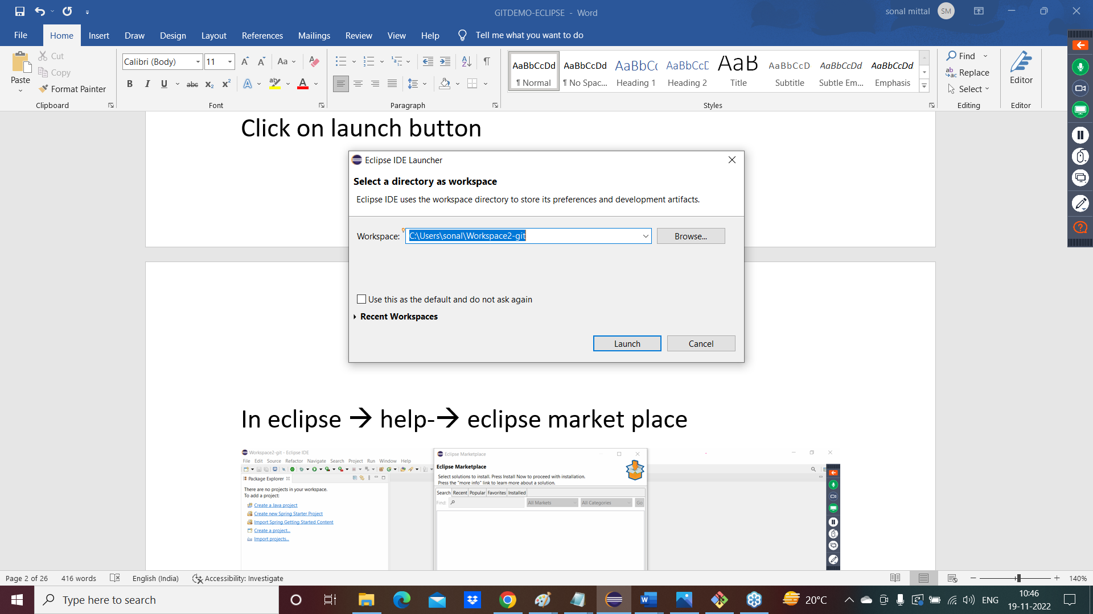

In eclipse 🡪 help-🡪 eclipse market place

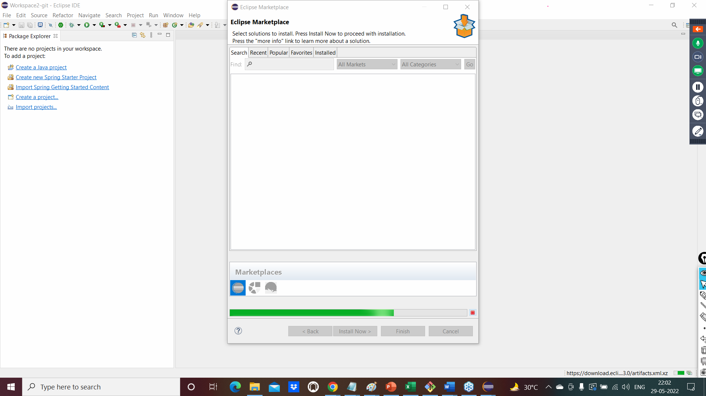

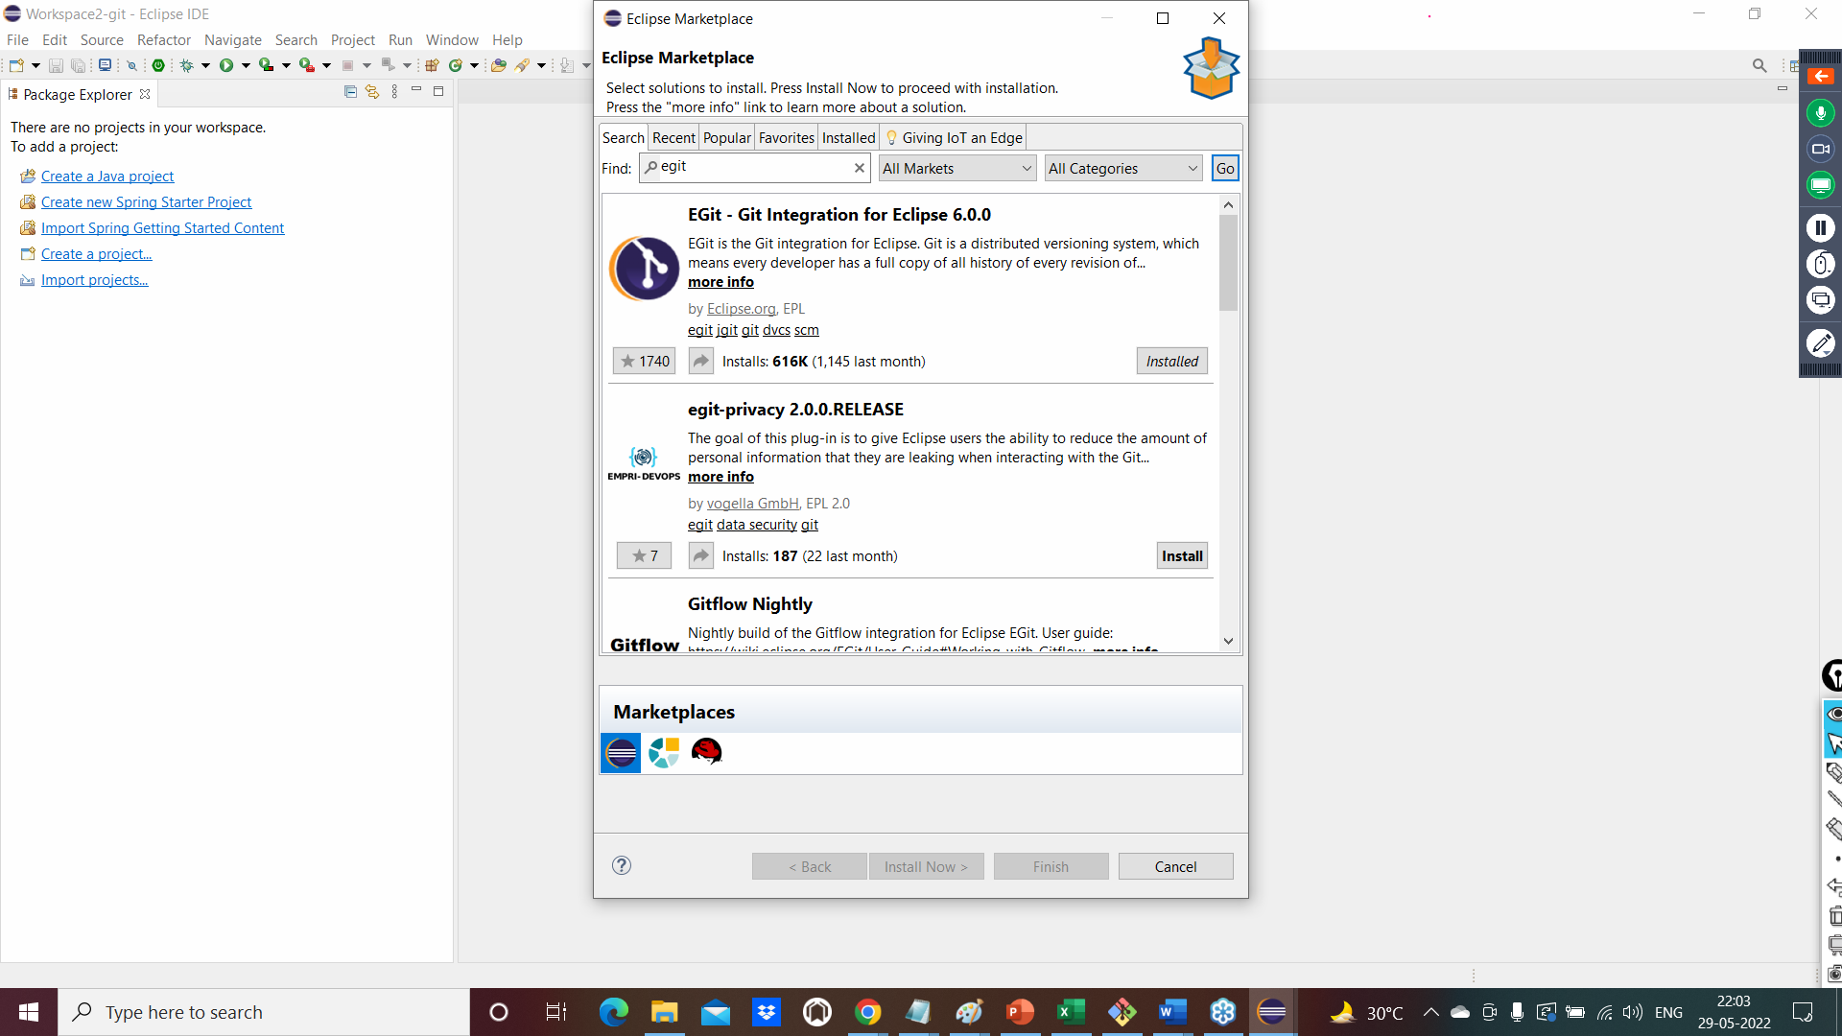

1. Open Eclipse

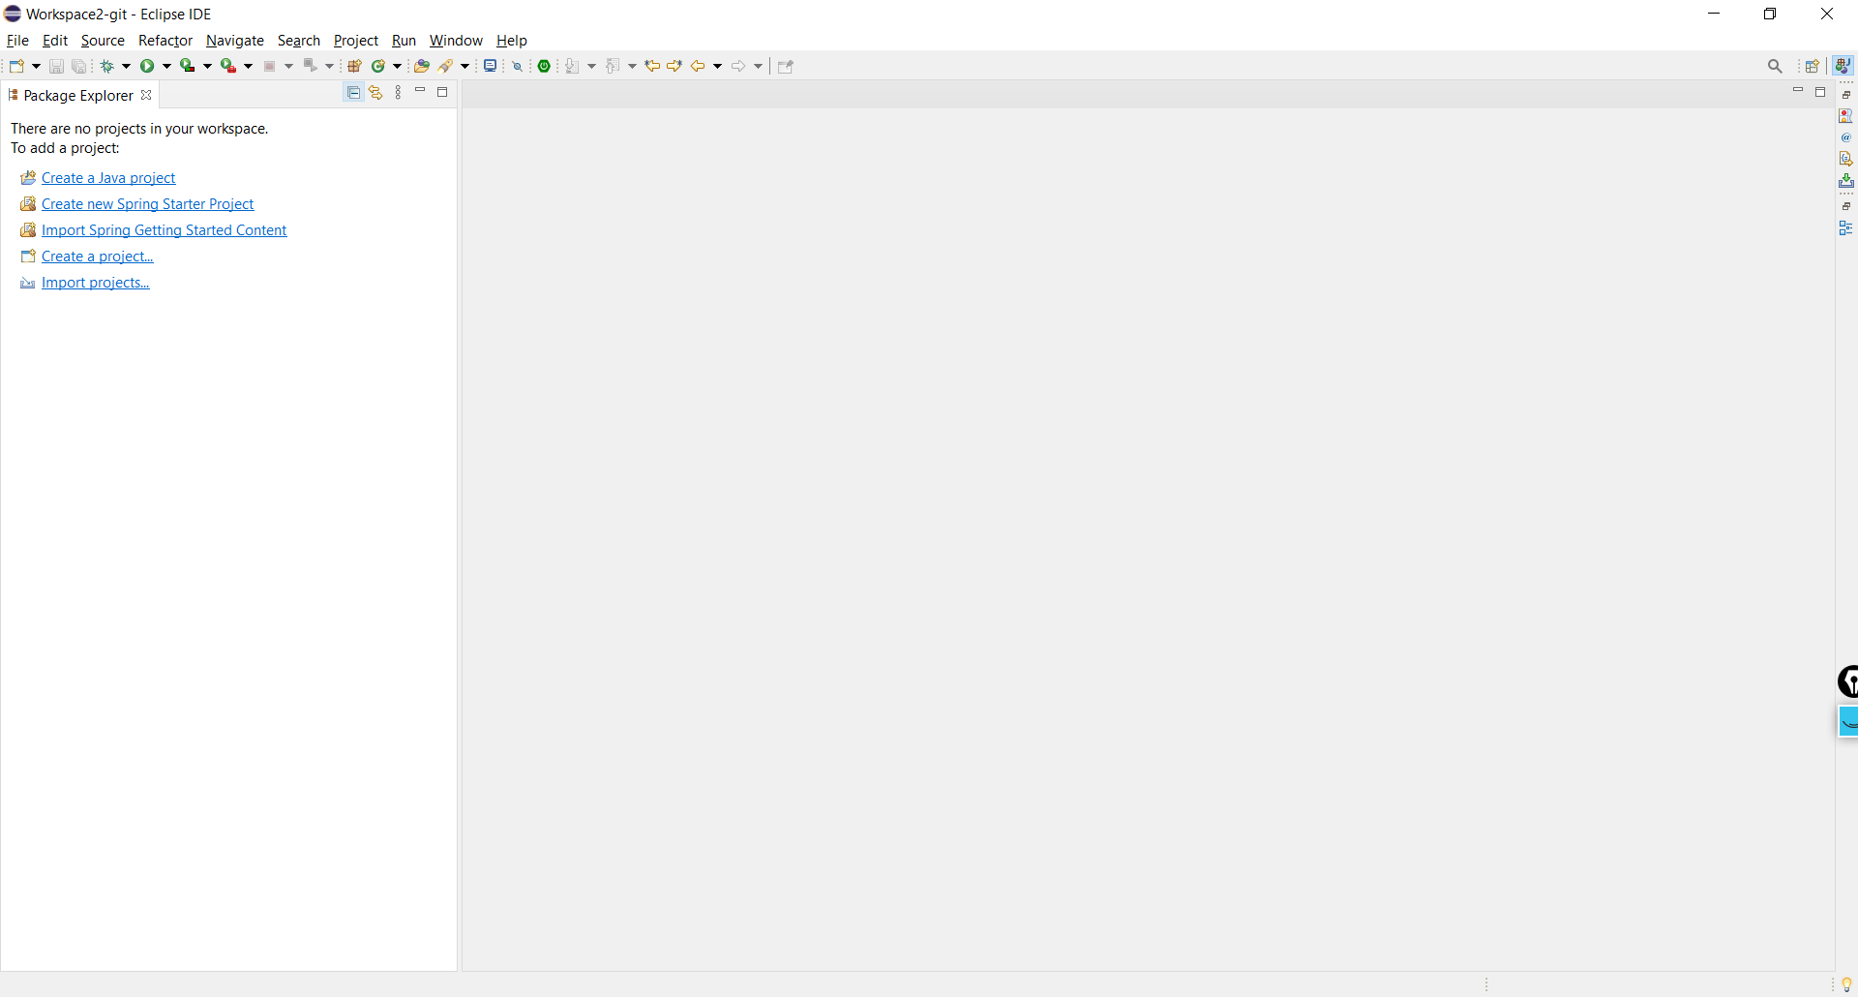

Create a Java project in eclipse for git demo:

Go to file 🡪 Click on New 🡪 Click on java project

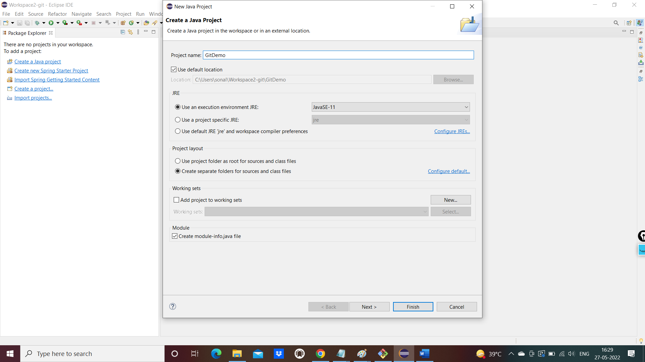

Click on Don’t Create as shown below

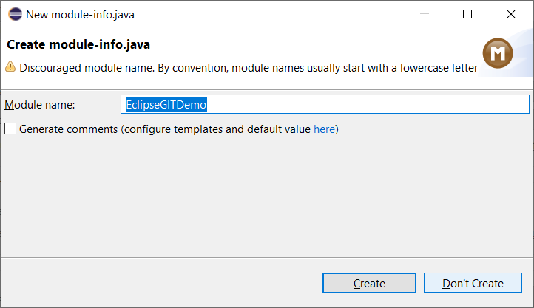

Create files inside the eclipse project

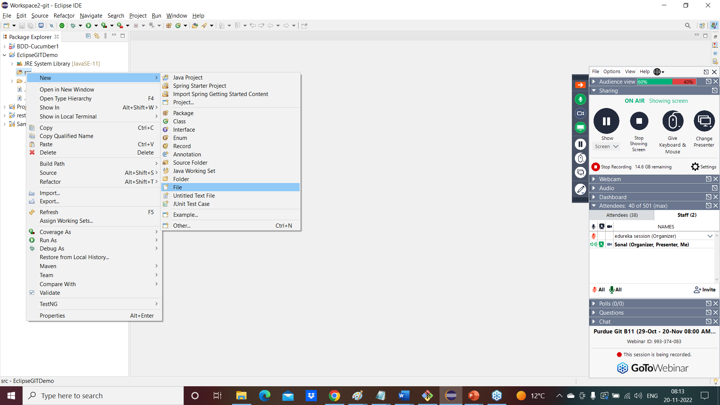

Add some lines in the new file created and save it

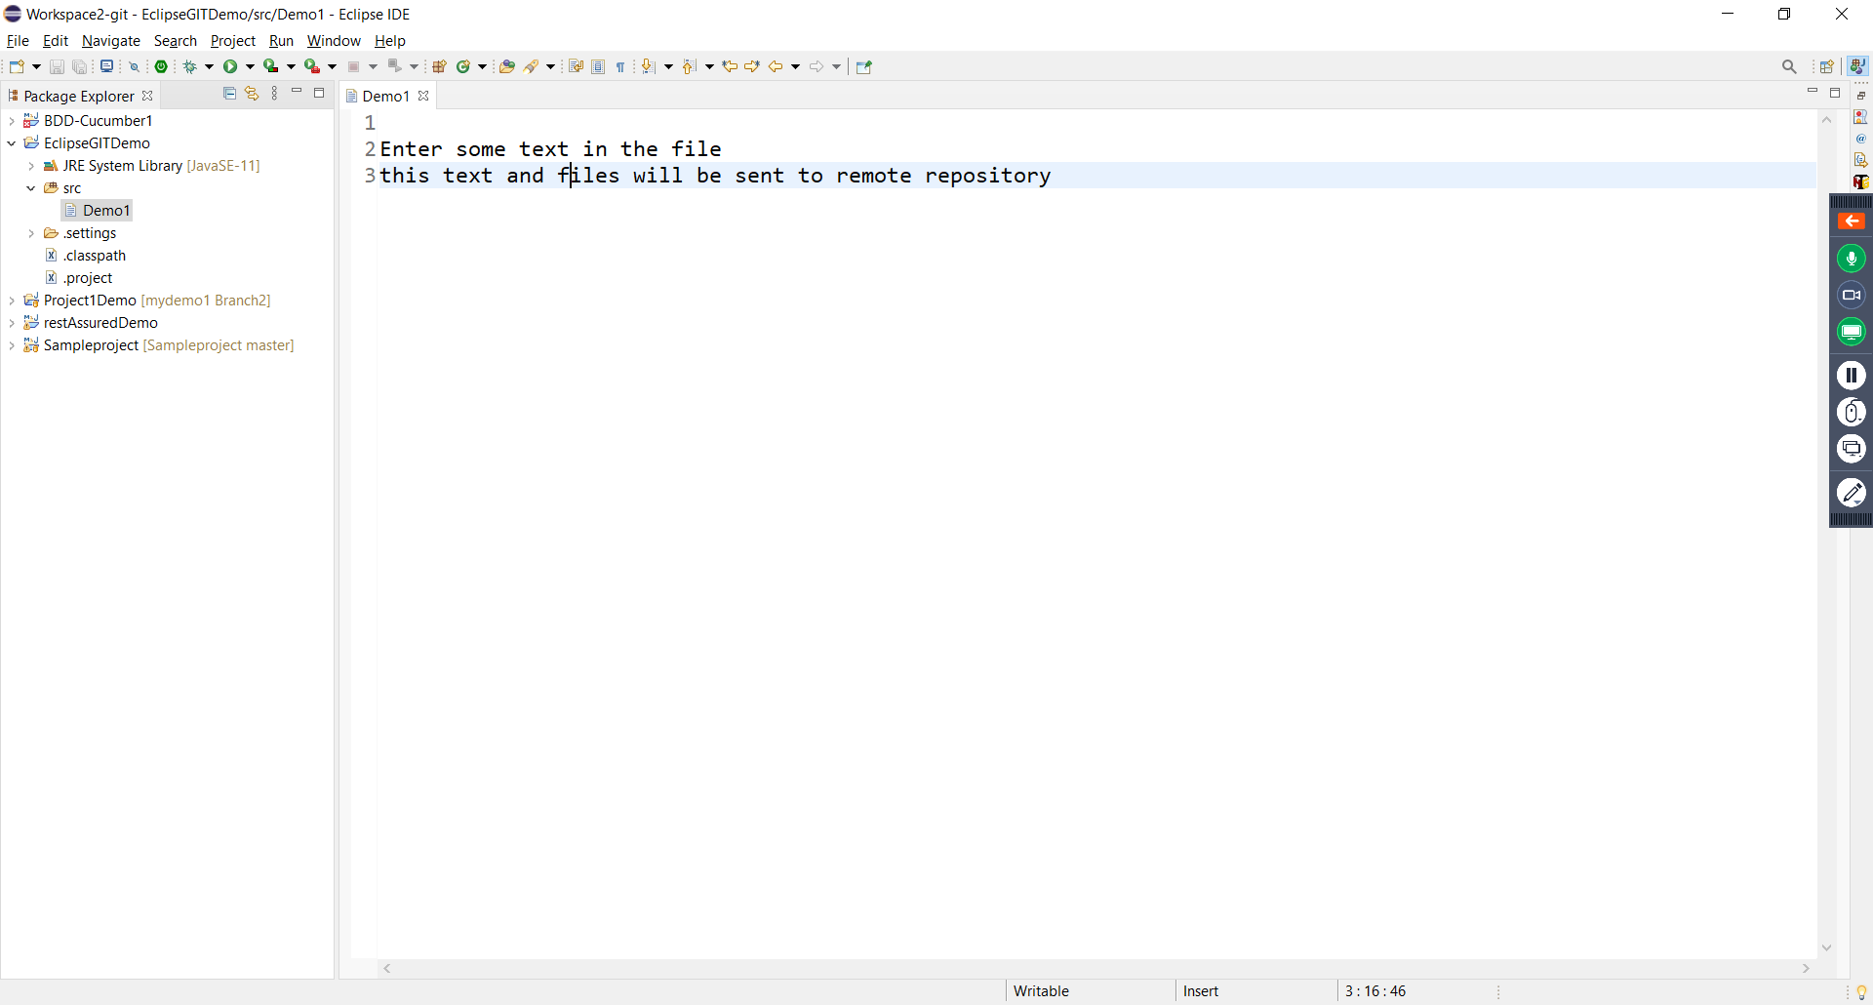

Create a Local repository

Right click on eclipse project and go to team

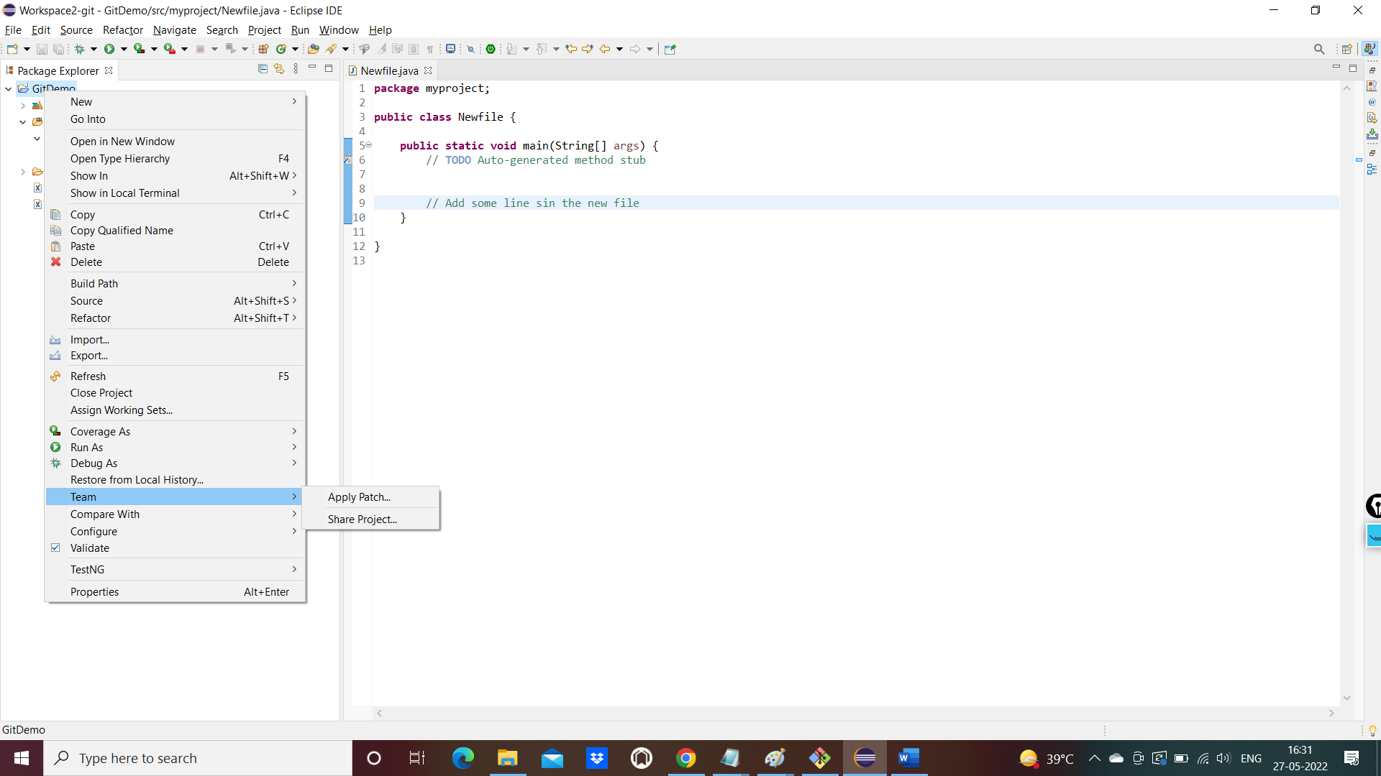

Click on Share project and click on checkbox

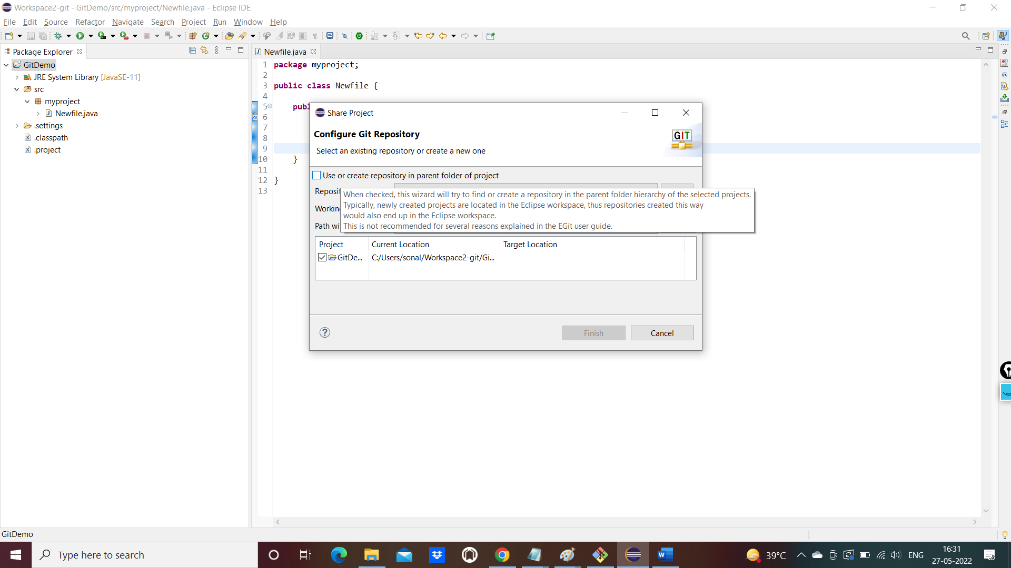

Click on create Repository button

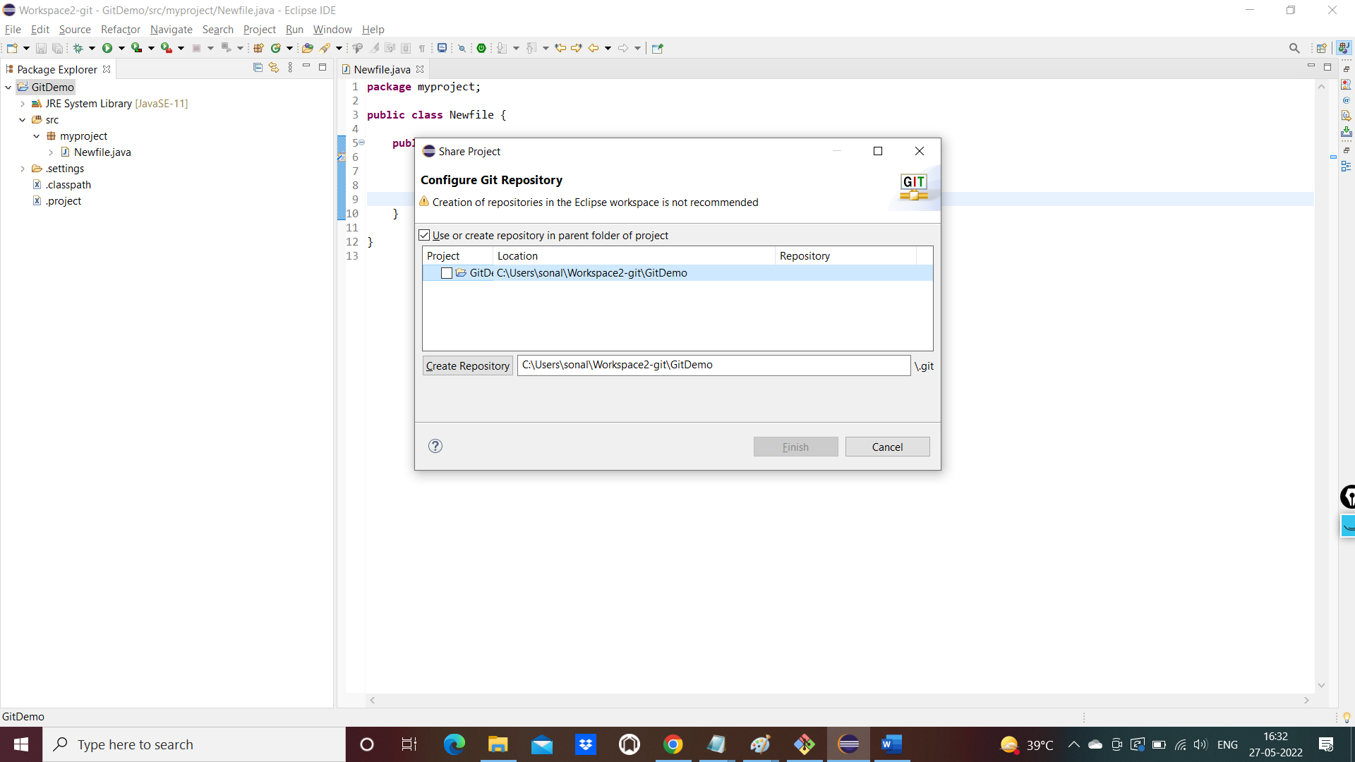

See the git view in eclipse

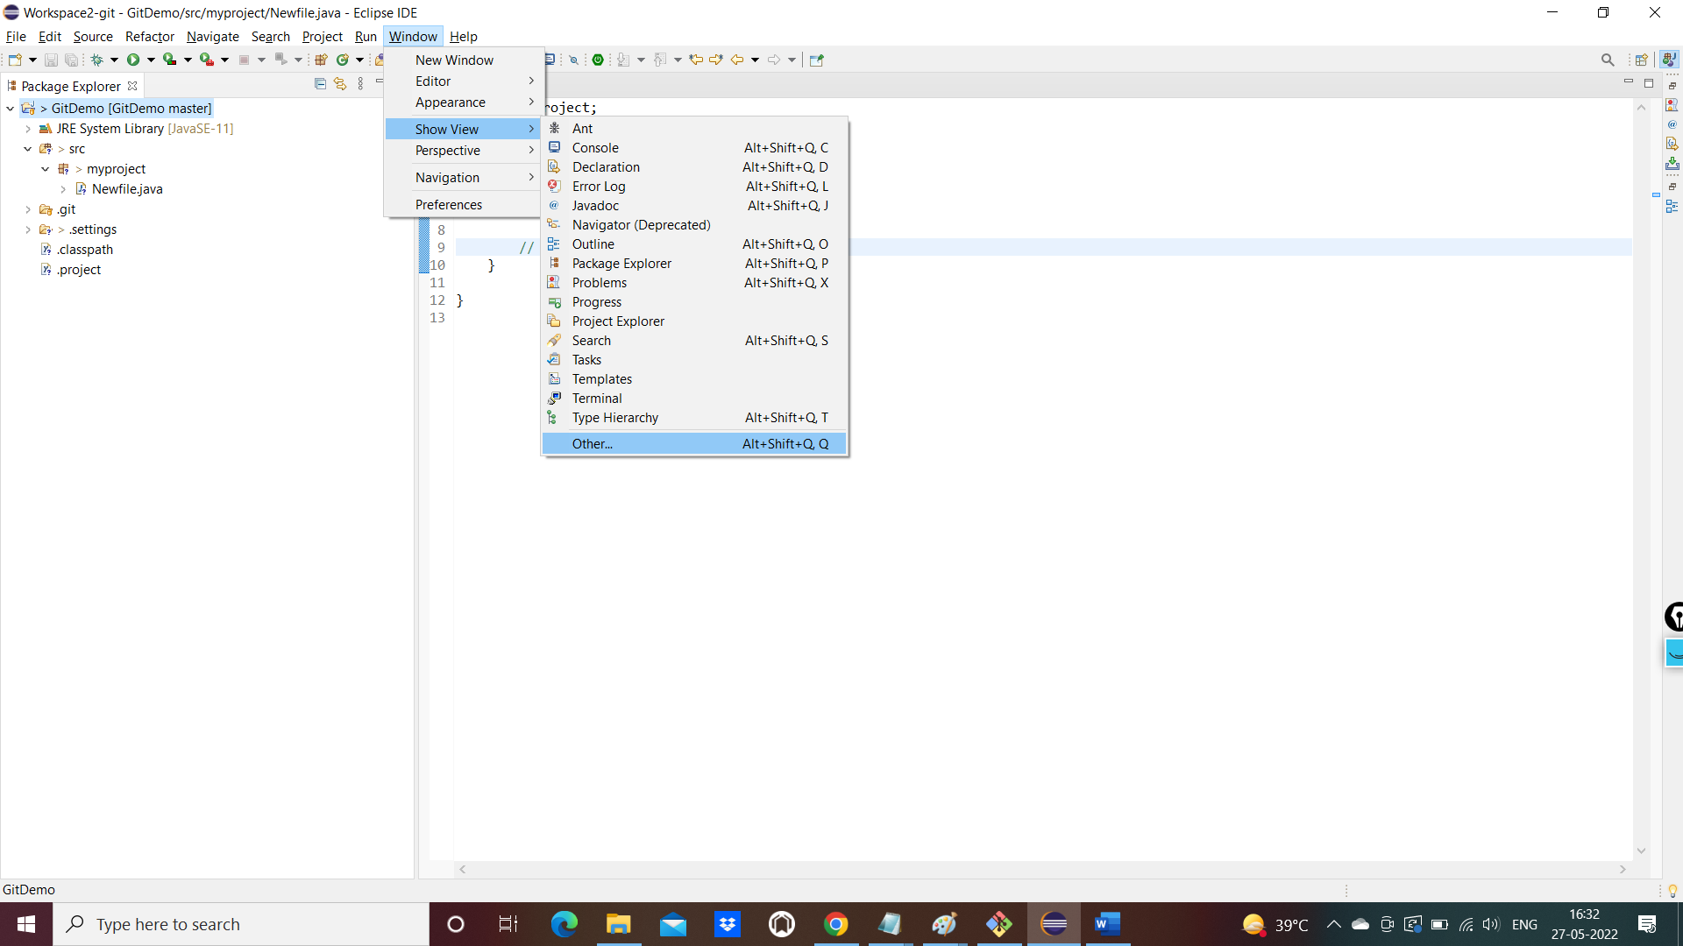

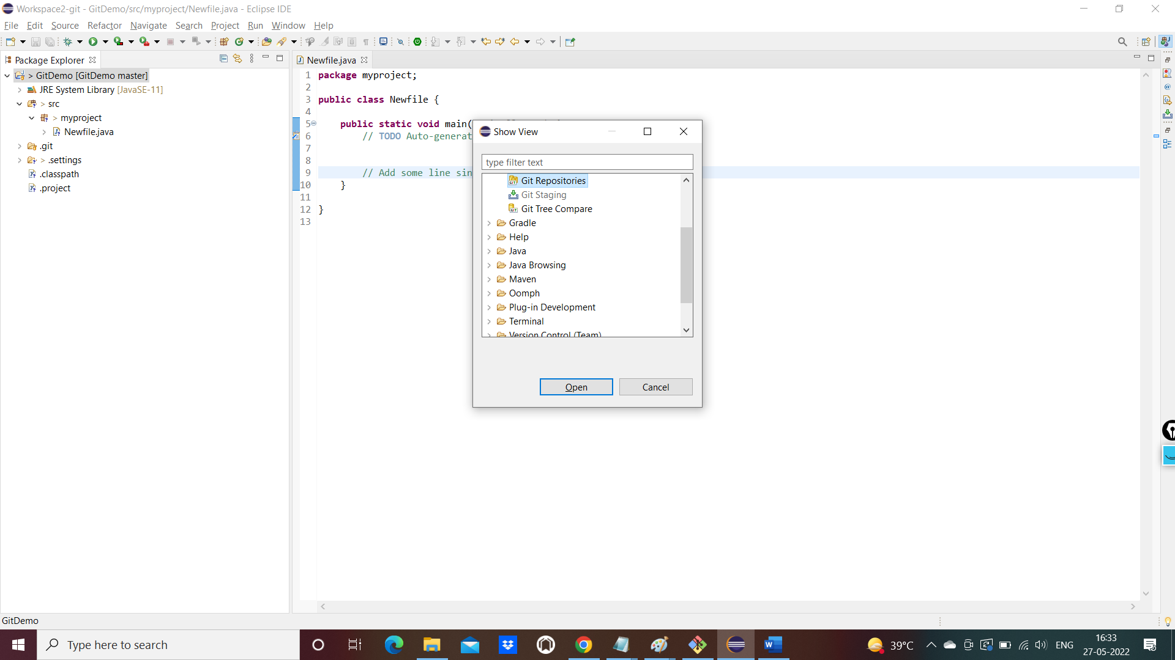

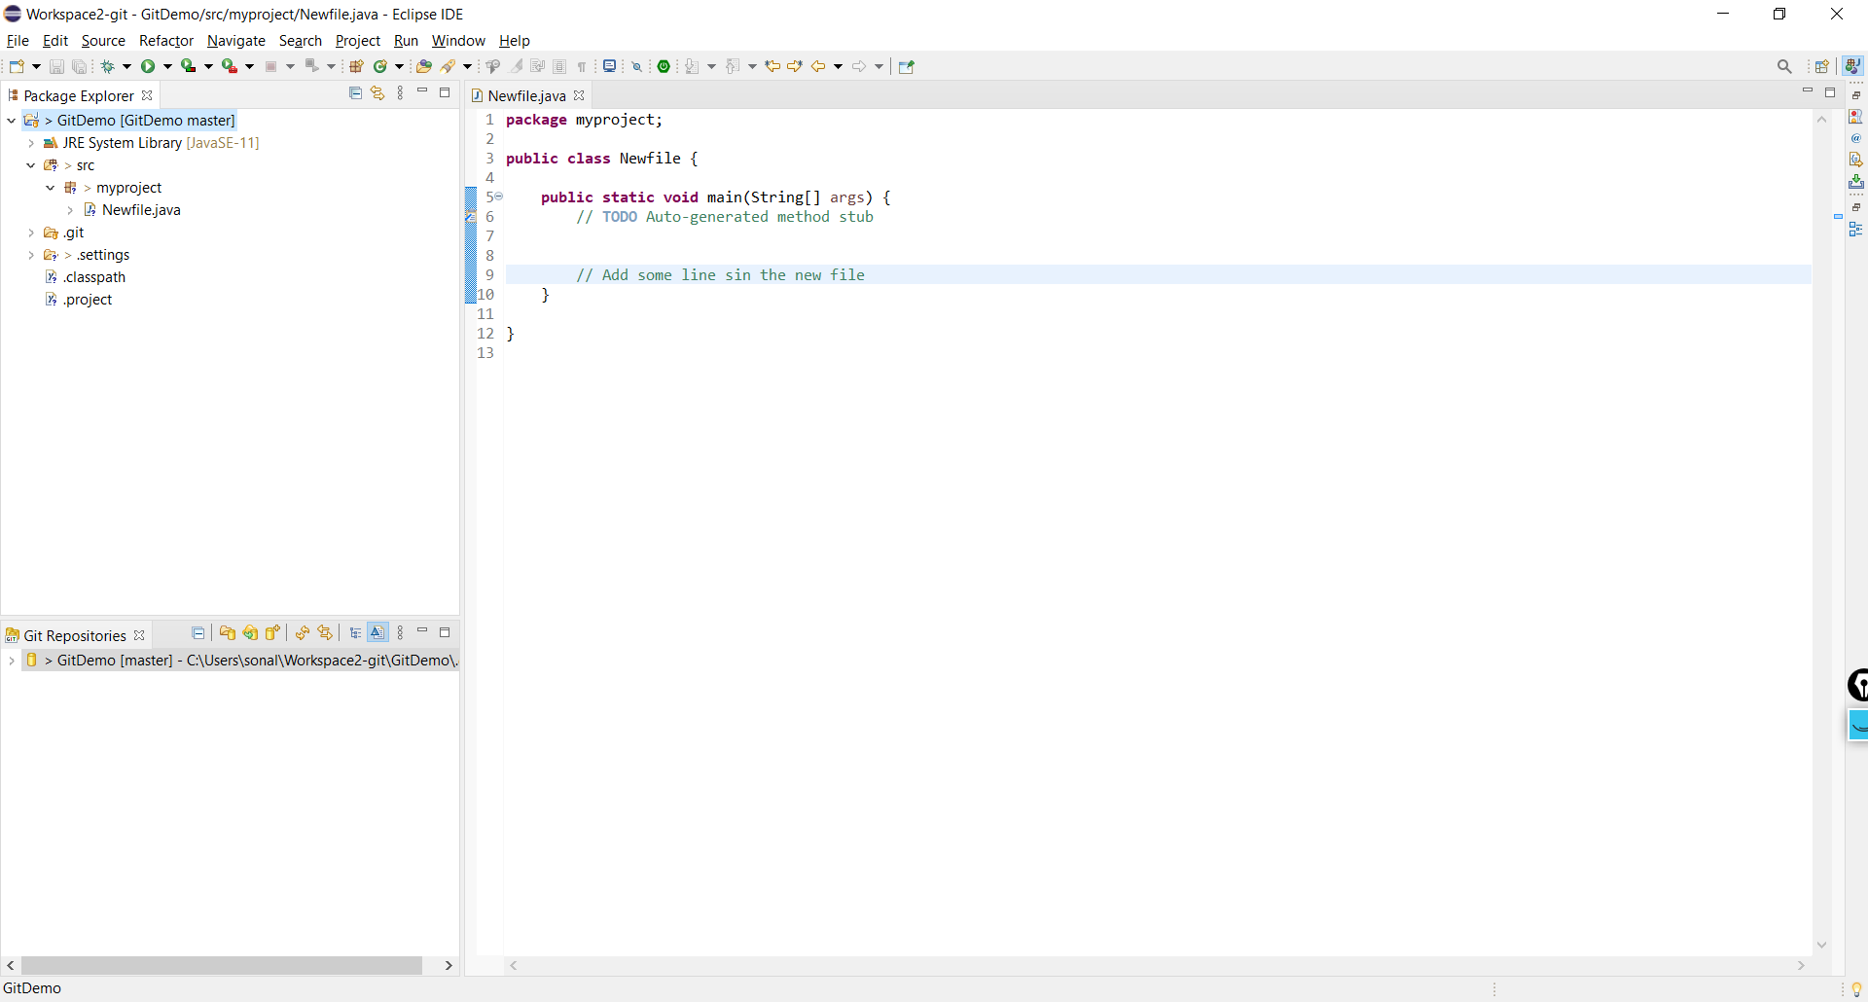

Add the files to Repo

\*\*\*\*\*\*\*\*\*\*\*\*\*\*\*\*\*\*\*\*\*\*\*

Right click on click on team🡪 add to index

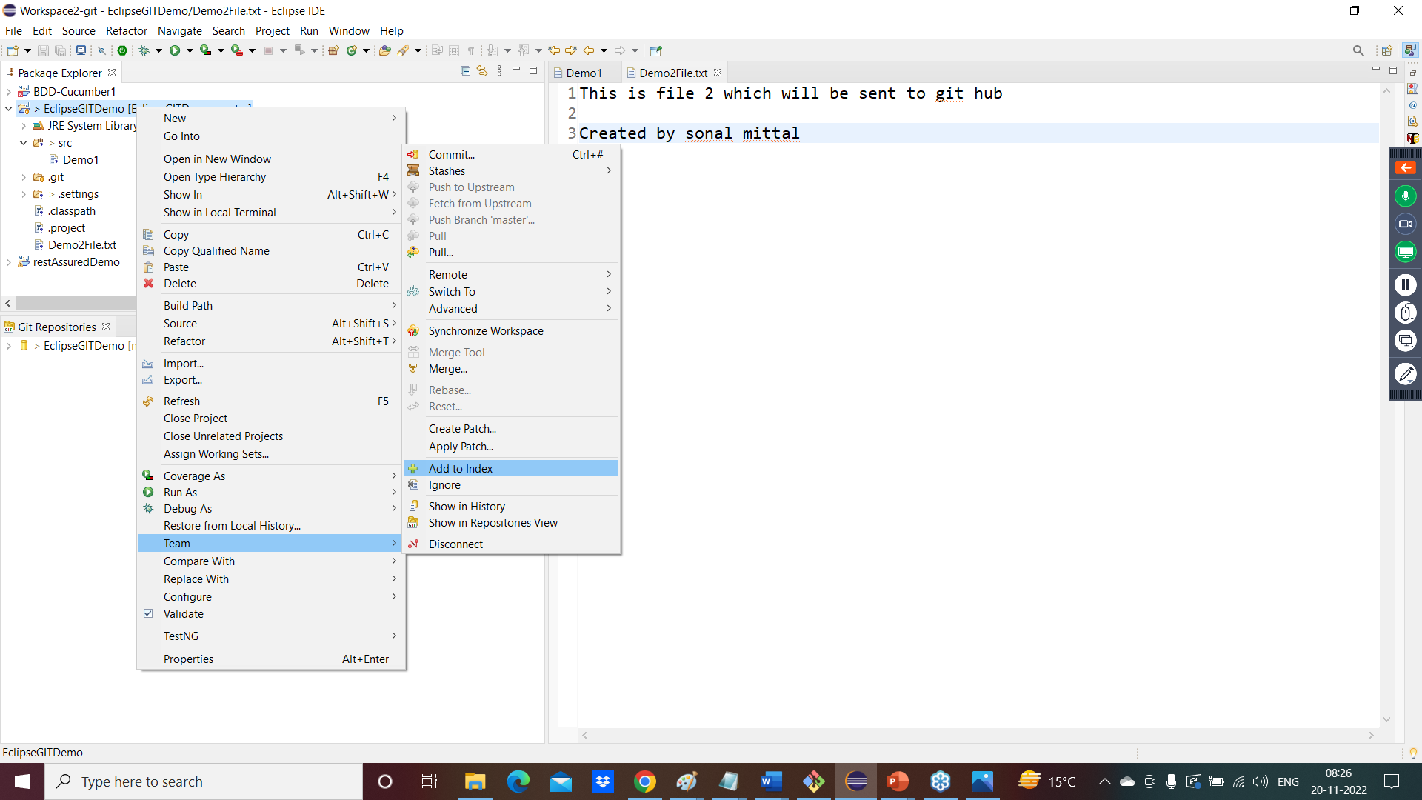

Right click on click on team🡪 Commit

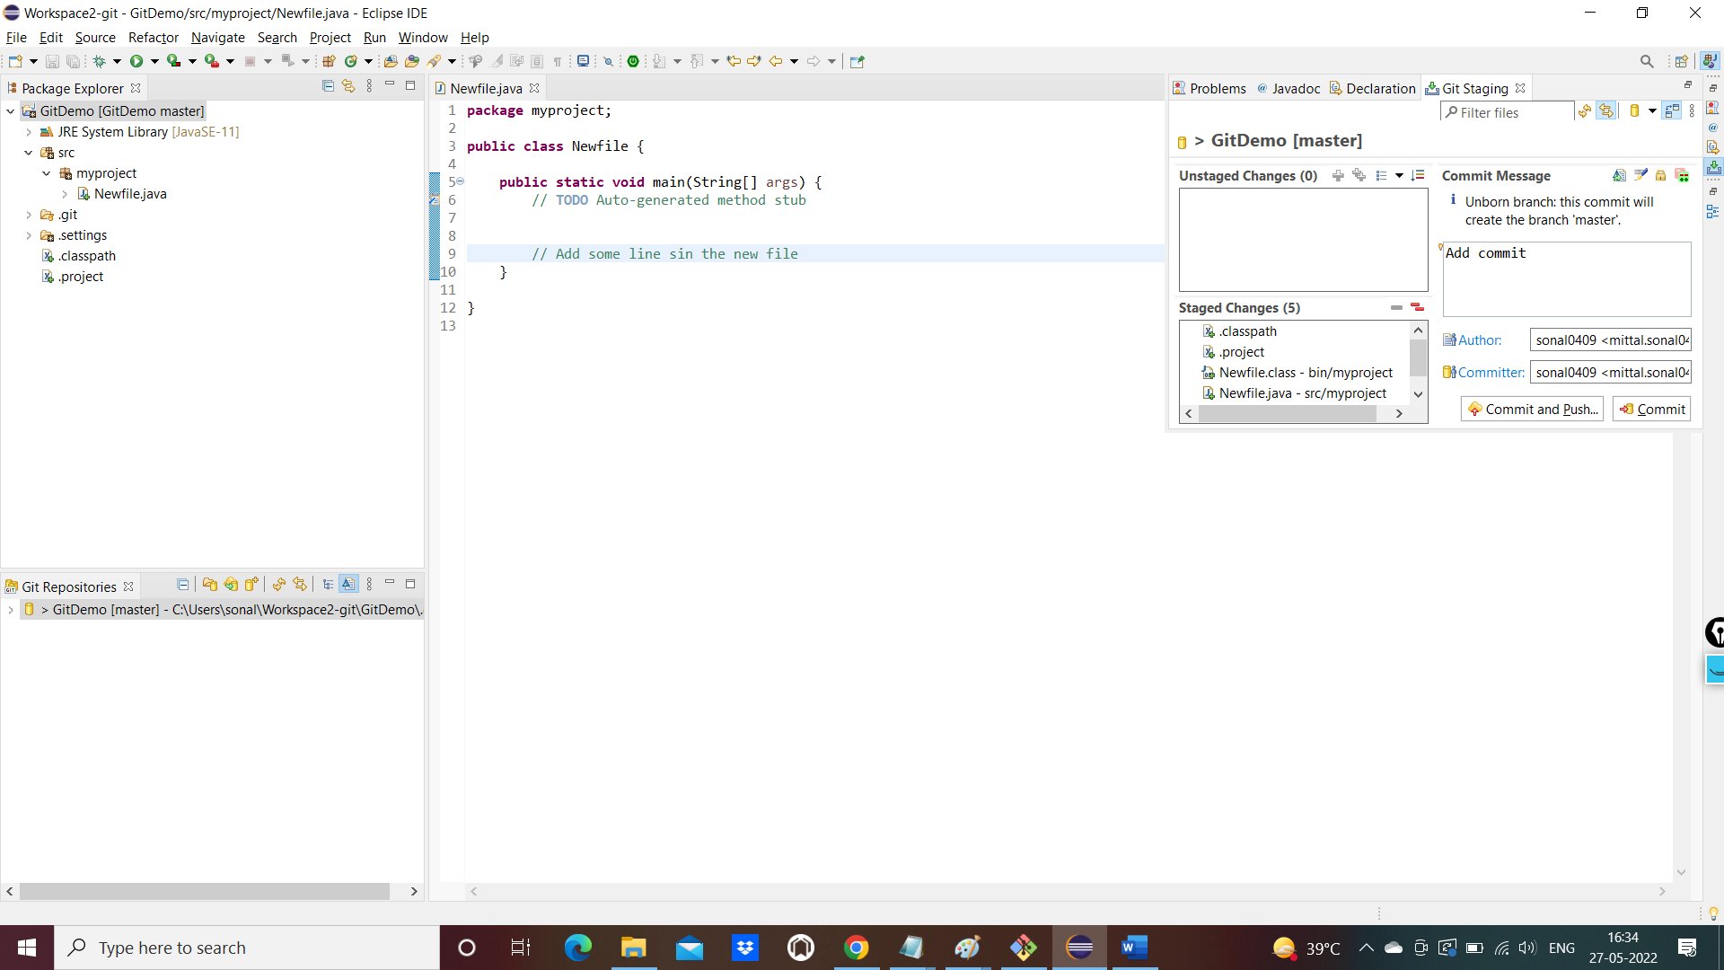

Push to remote repo

\*\*\*\*

Create a Repo in github

\*\*\*\*\*

Take the ssh path:

[git@github.com:Sonal0409/eclipsedemo.git](mailto:git@github.com:Sonal0409/eclipsedemo.git)

OR HTTPS path

https://github.com/Sonal0409/giteclispedemo20.git

Right click on repo🡪team🡪remote🡪push

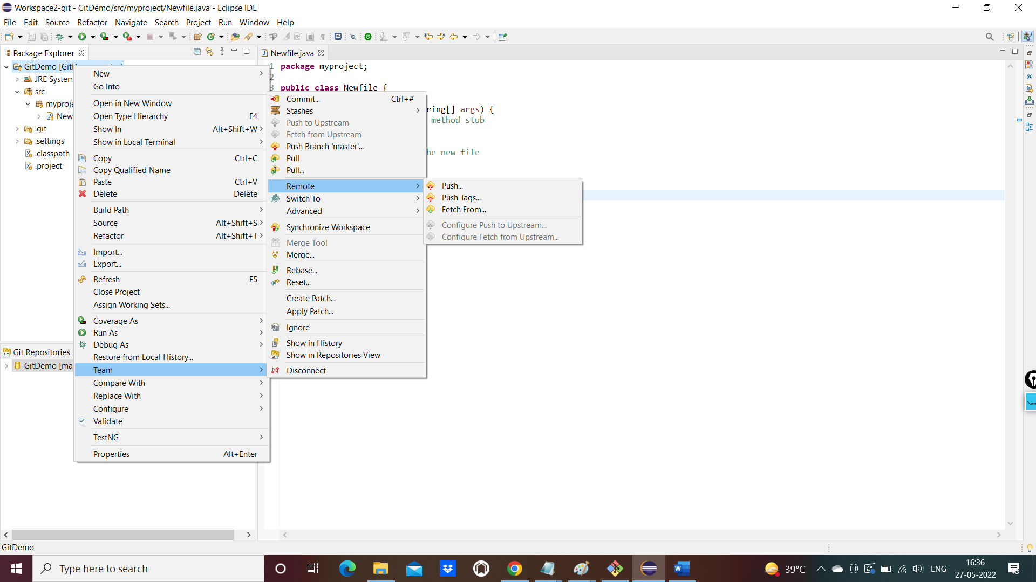

Give the github repo url

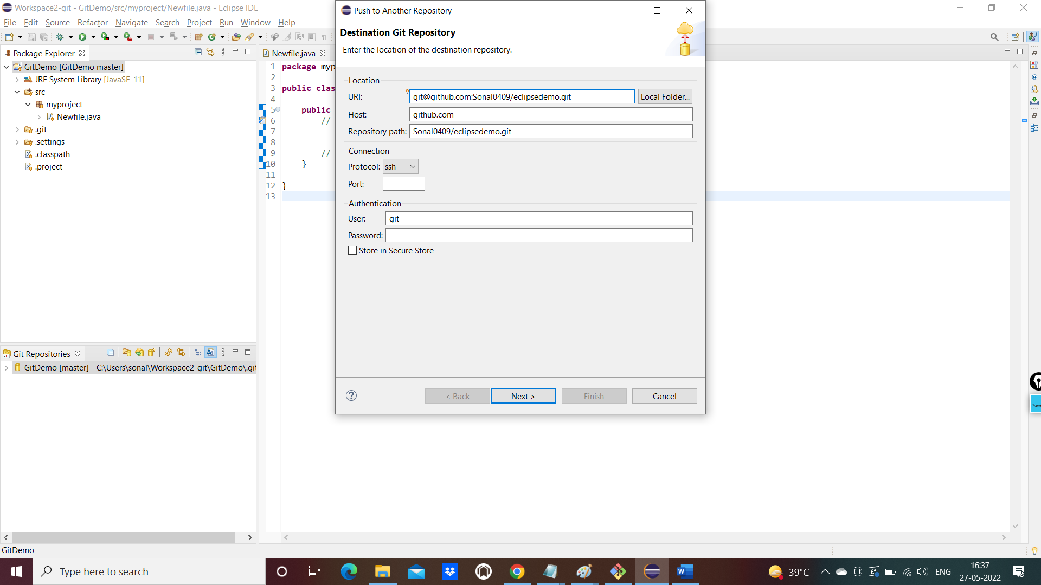

Select branch as master under ref and click on Add spec

Click on finish button

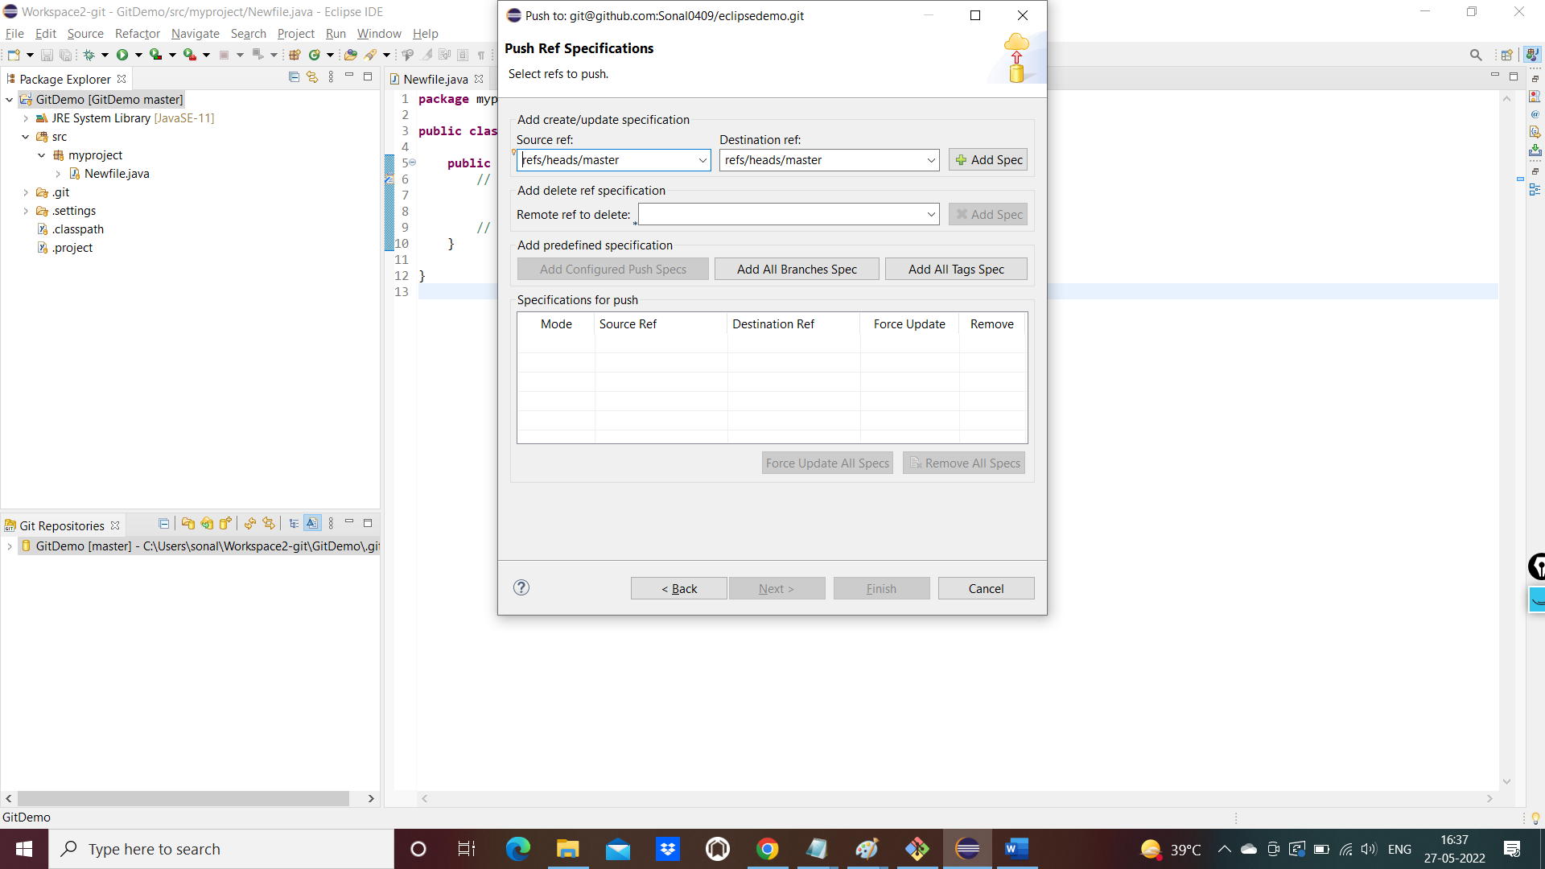

Push will be complete

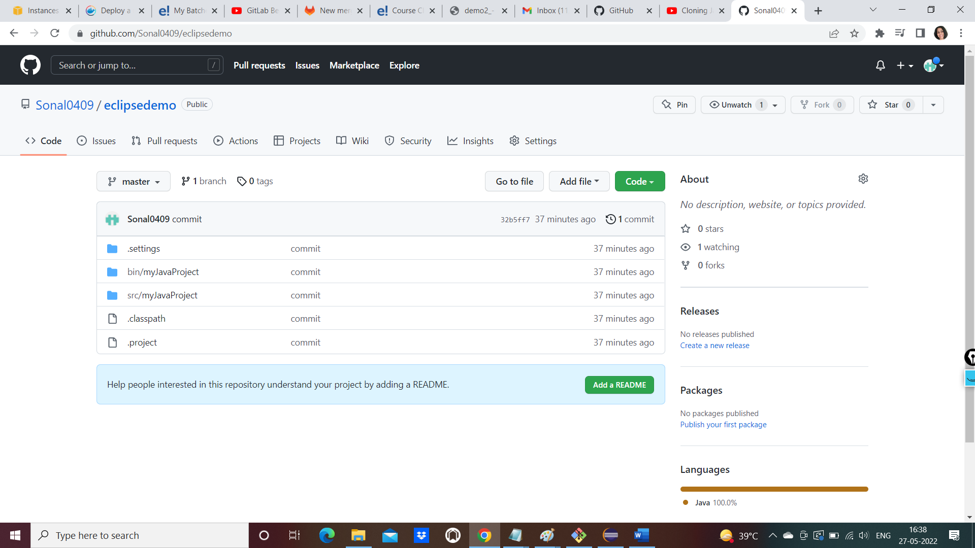

Clone a repo from GITHUB to eclipse:

Delete the existing project and repository in eclipse for this scenario

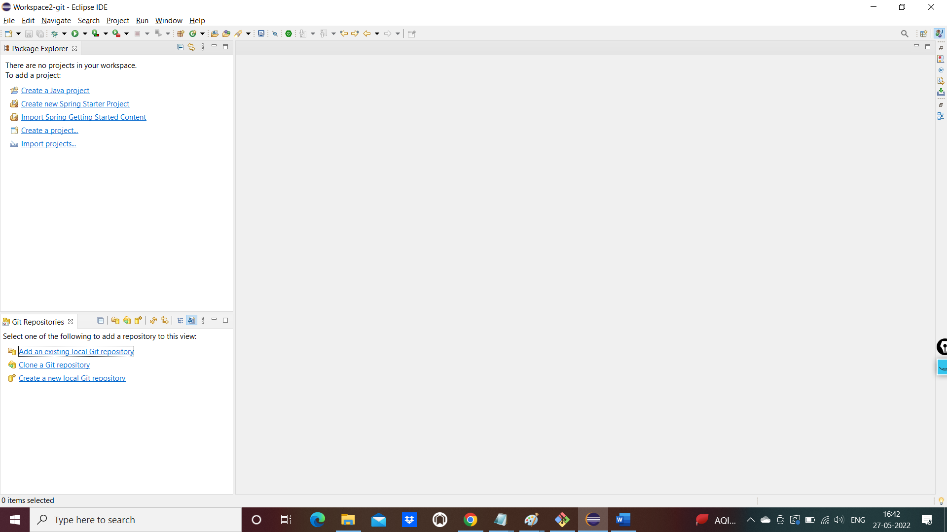

Click on clone a repository

Give the ss hurl of github repo

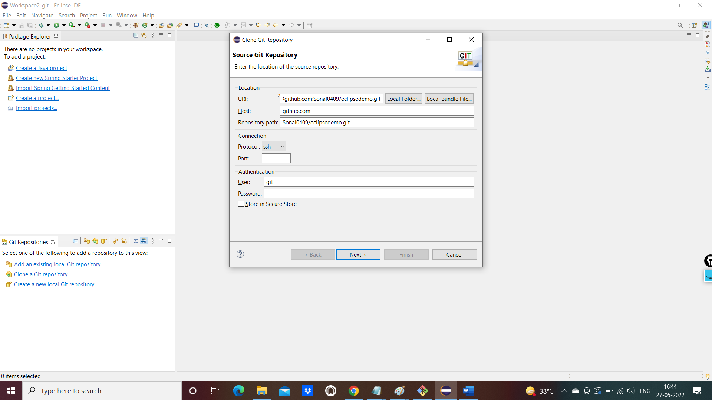

Press next button , again next button and click on finish

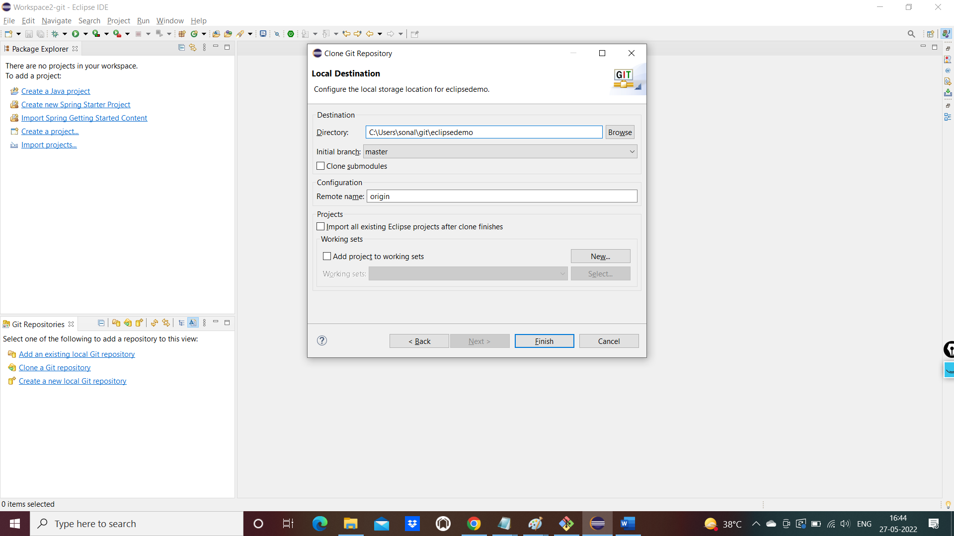

Repo will be cloned in git folder

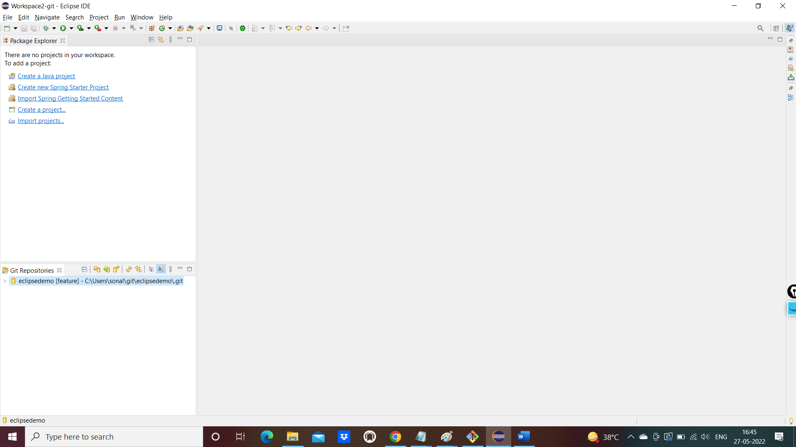

You need to import the repo to eclipse workspace

Click on import projects

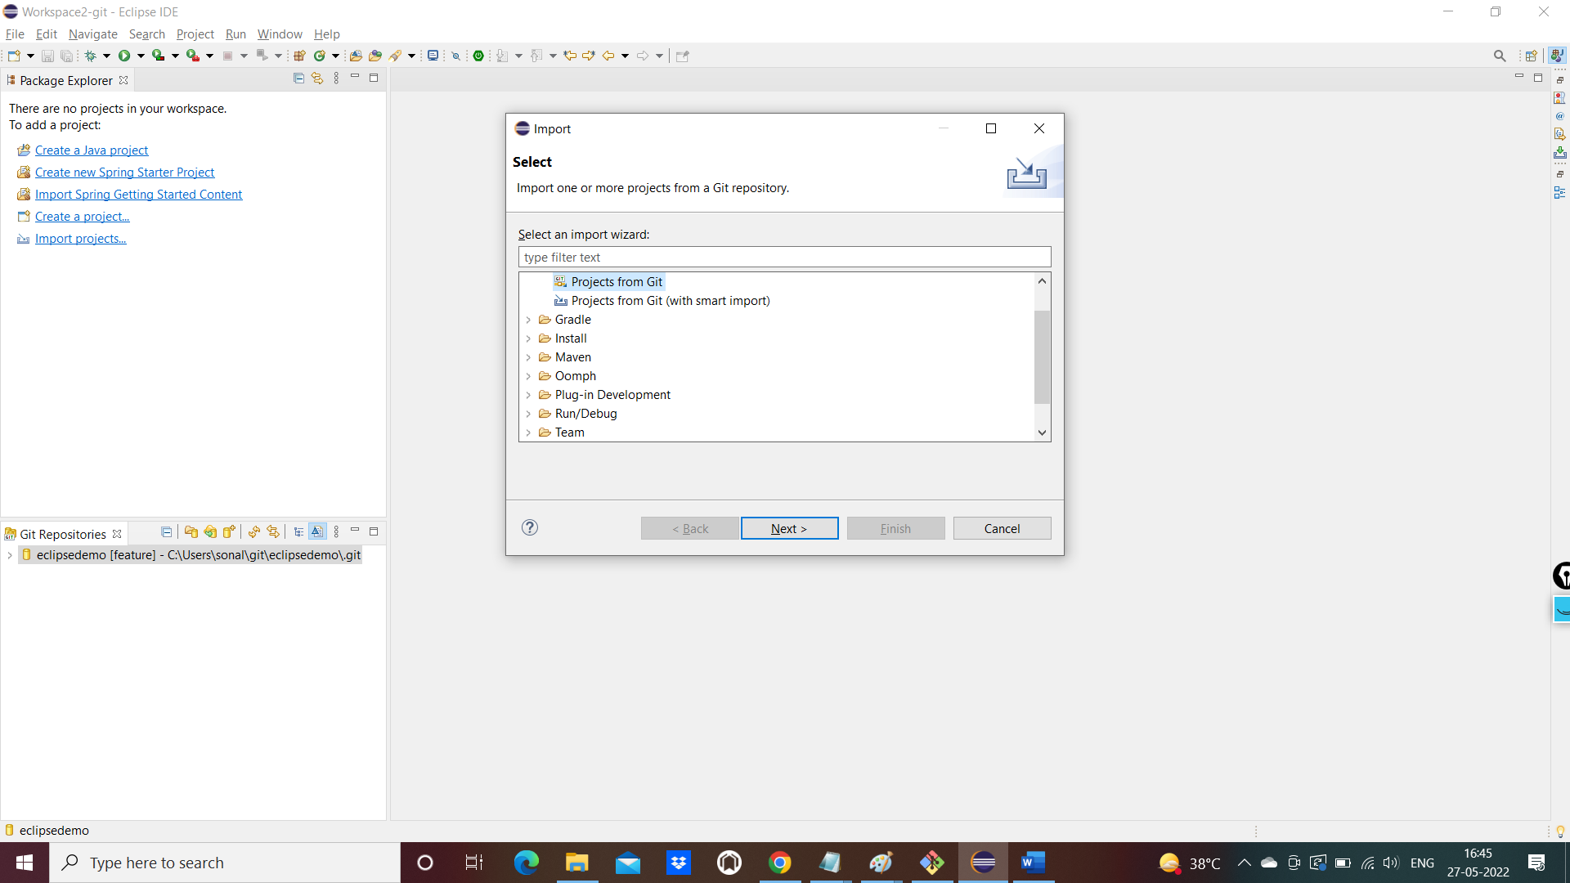

Select projects form git 🡪 select local repository

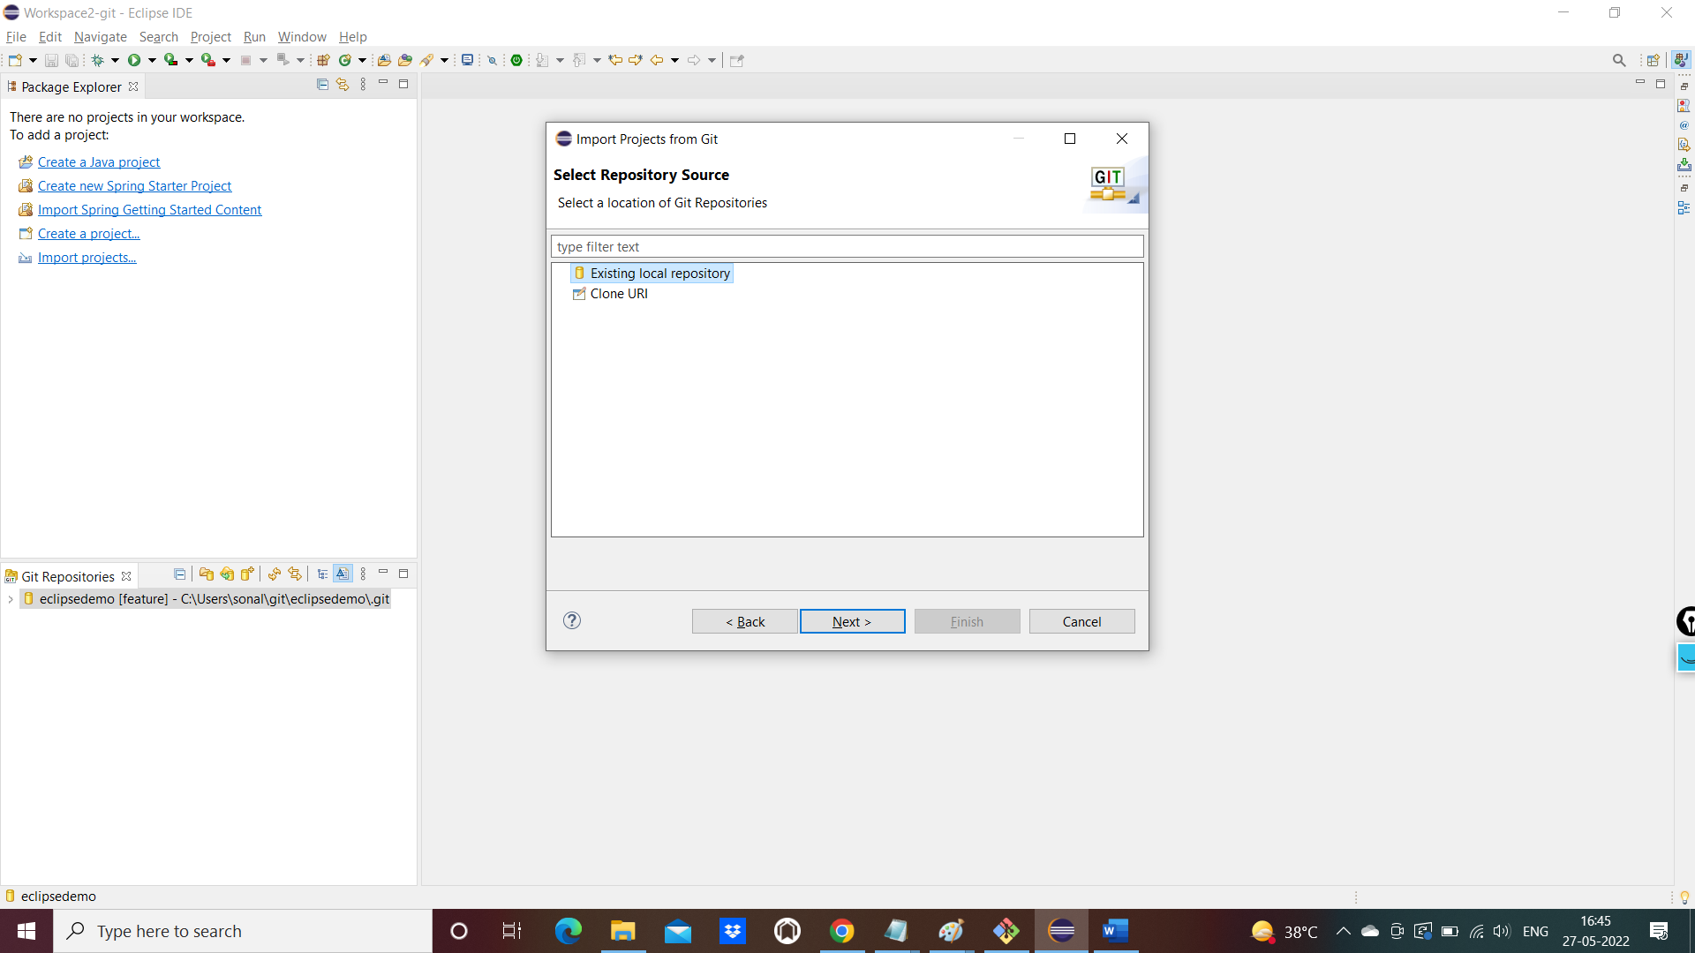

Press next 🡪 again next 🡪

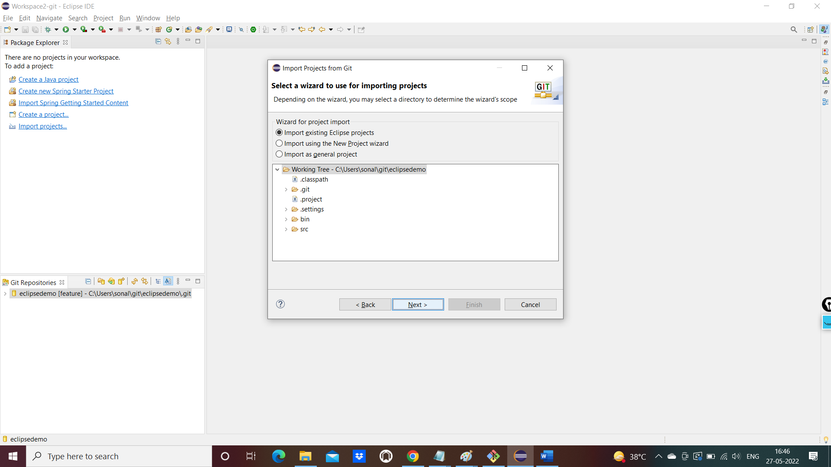

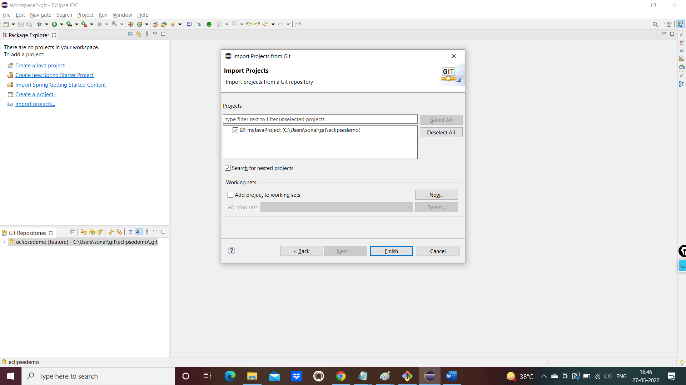

Click on finish button

Project will be in the project explorer window

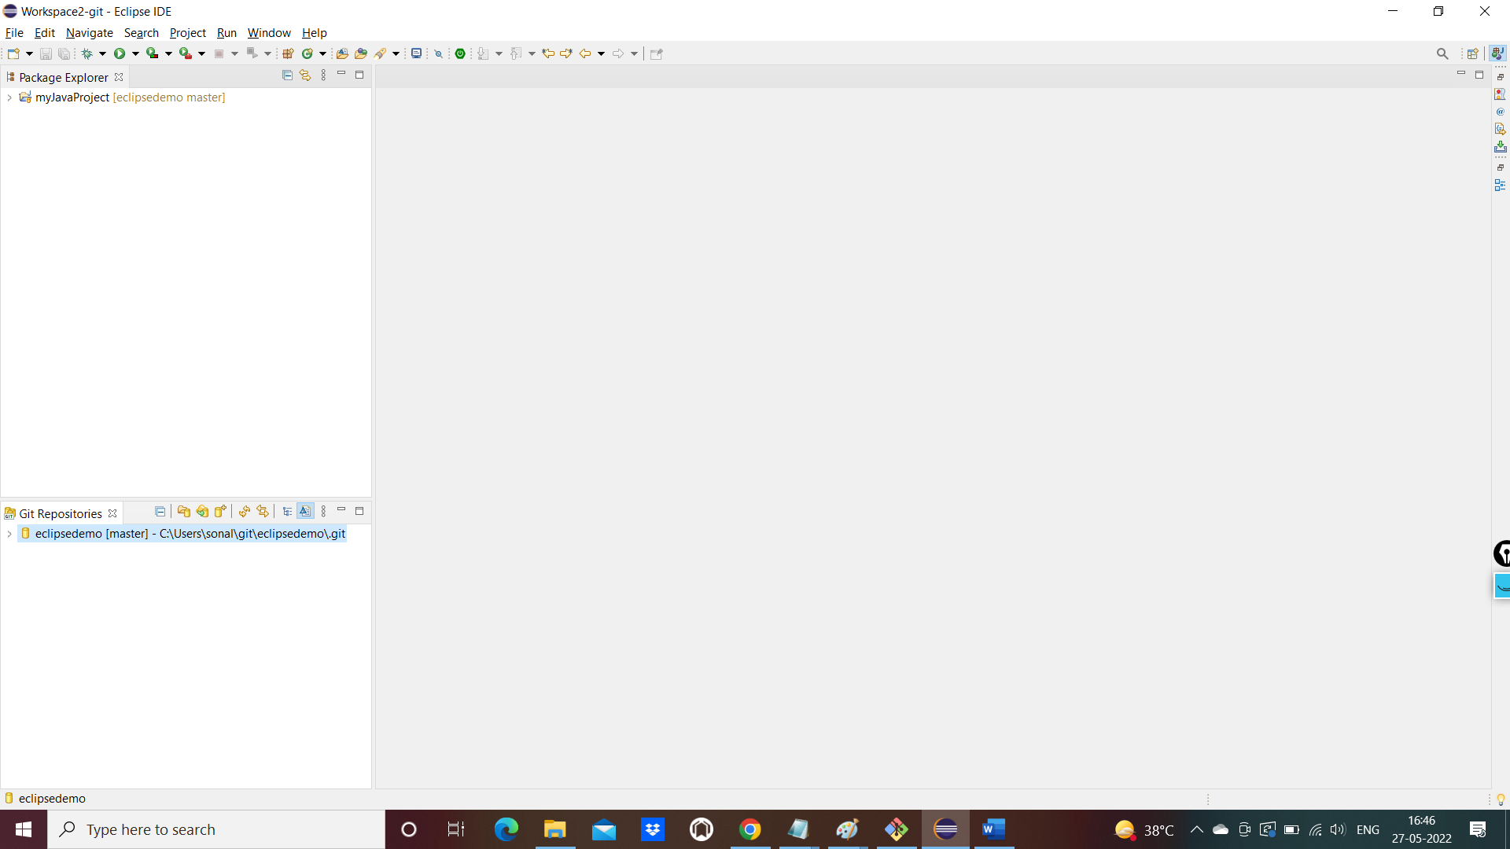

Files are there in the project

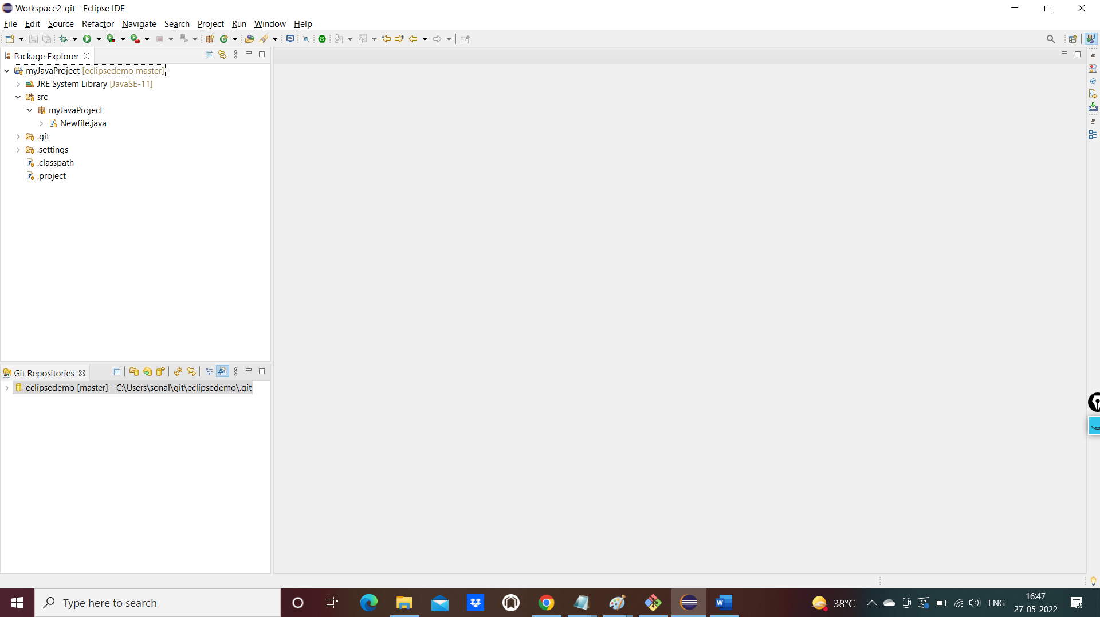

Create a branch now in this local repo

Open the git repositories:

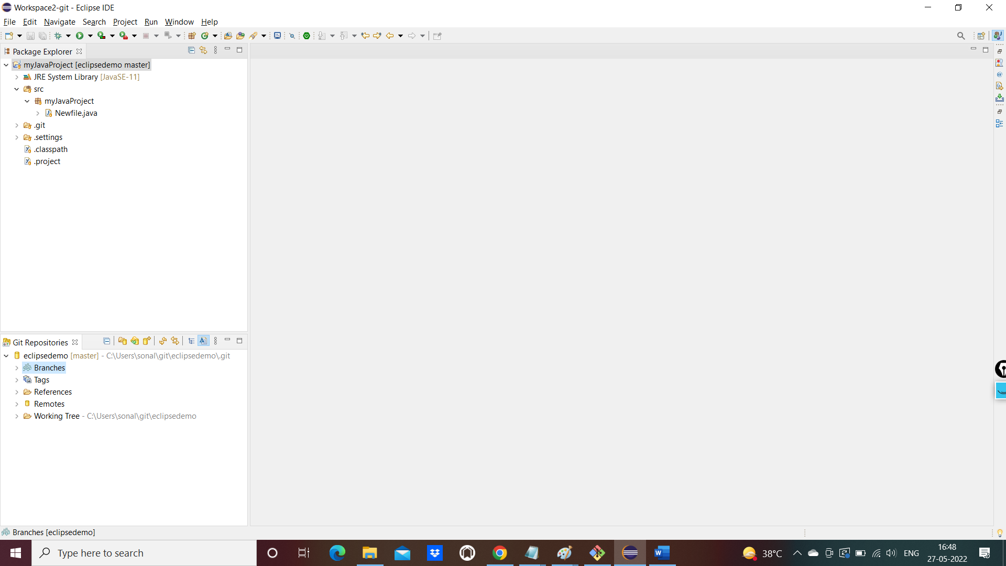

Right click on branchs 🡪switch to-> create new branch

Give a branch name:

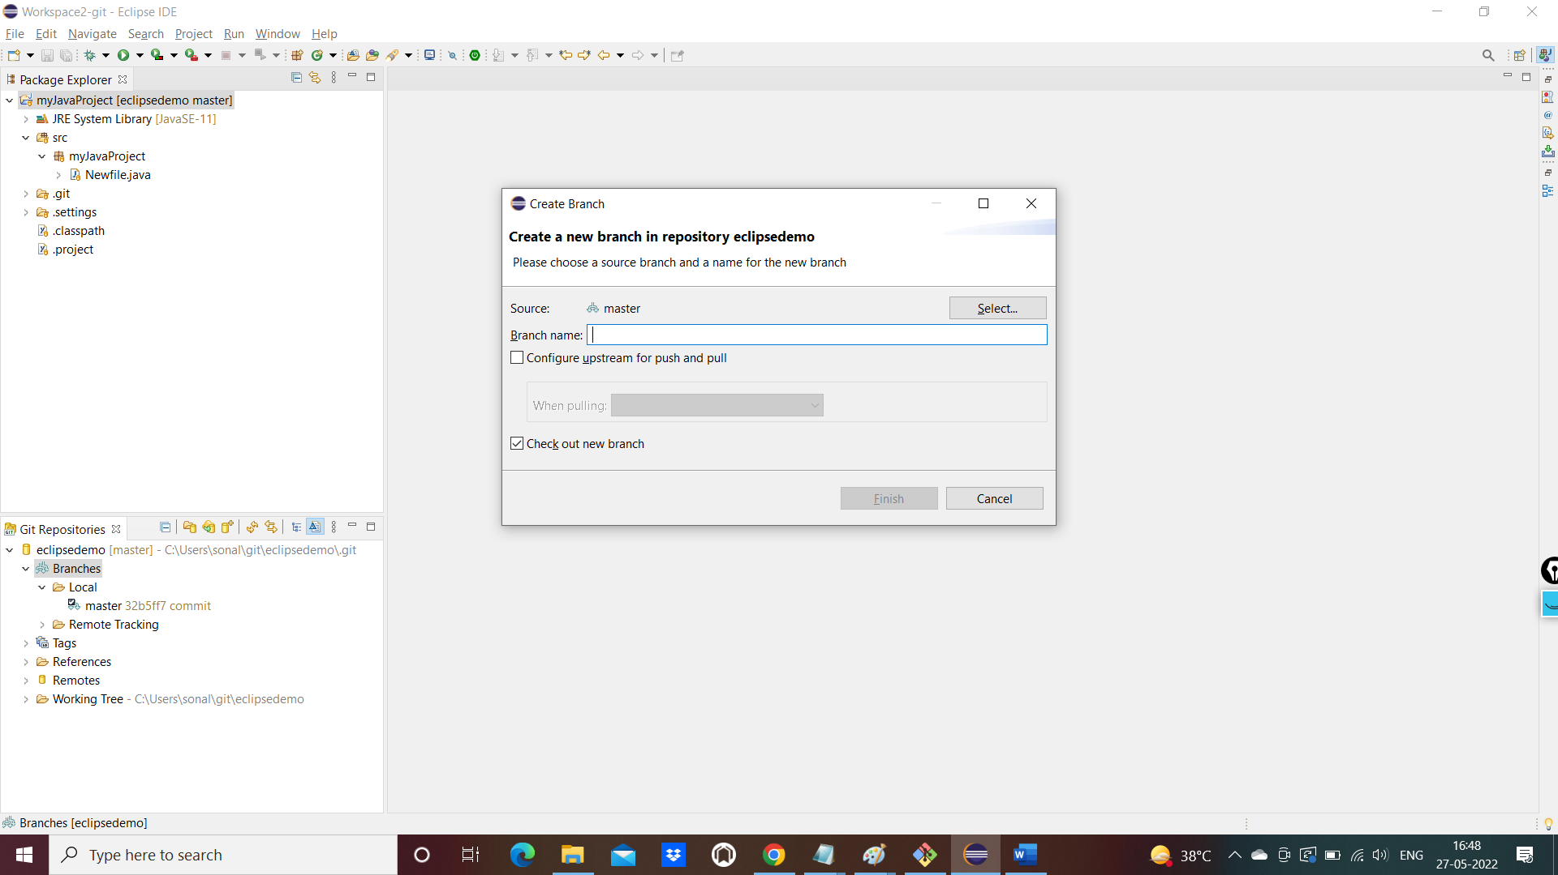

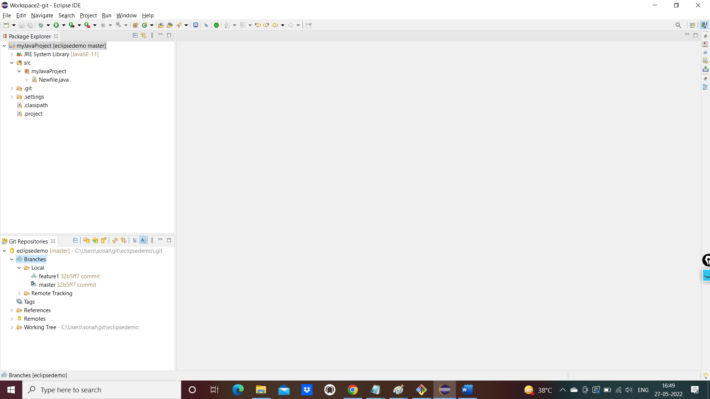

Double click on feature1 branch to switch to it

Refresh the project to reflect the branch

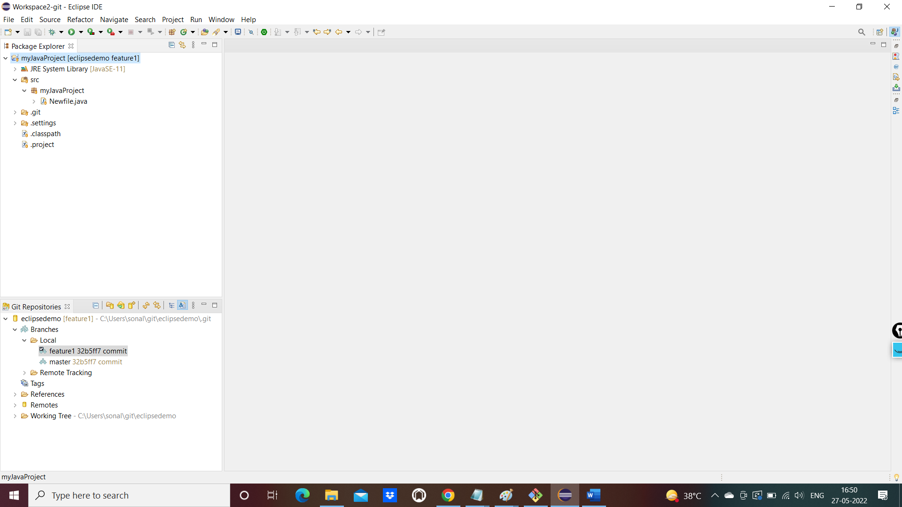

Create a new file on feature branch

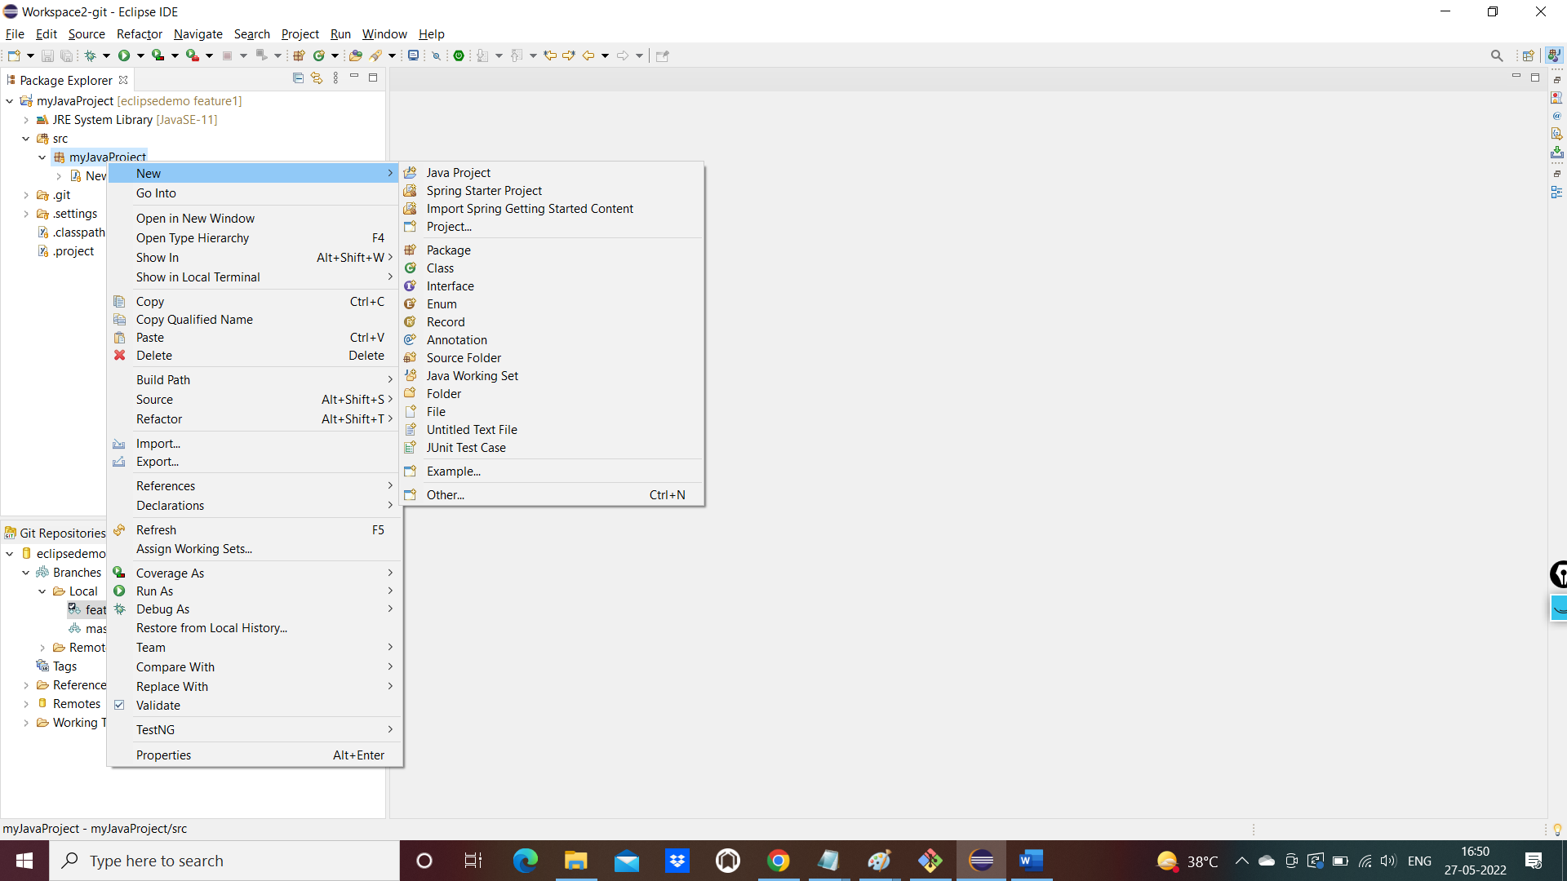

Write something in the file and save it

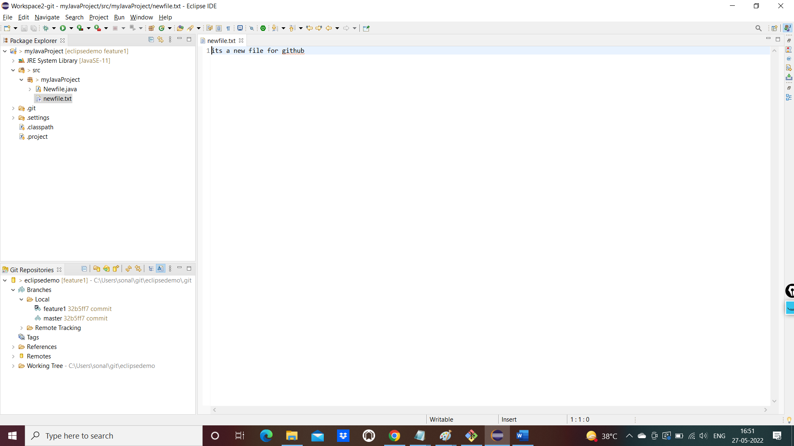

Commit on the branch

Right click 🡪 team 🡪 add to index🡪 commit

Add more change to file and save the file and refresh if commit is not happening

Click on commit button

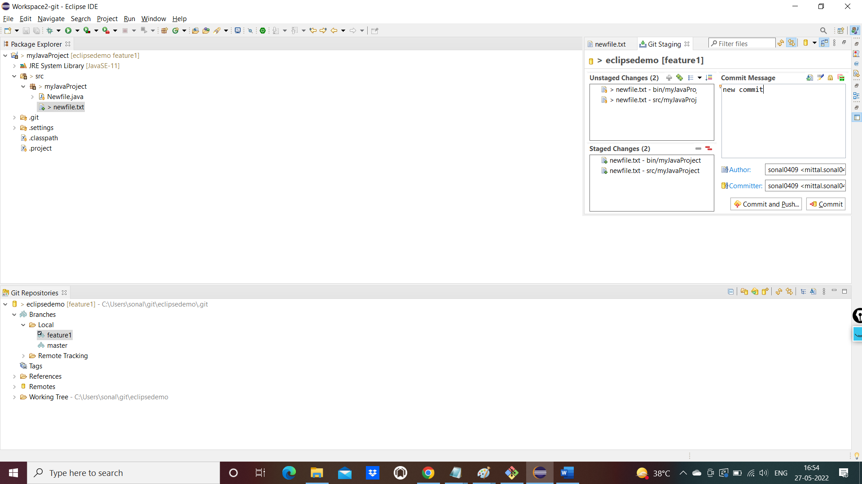

Switch to master and see the file is not available.. that commit is not there

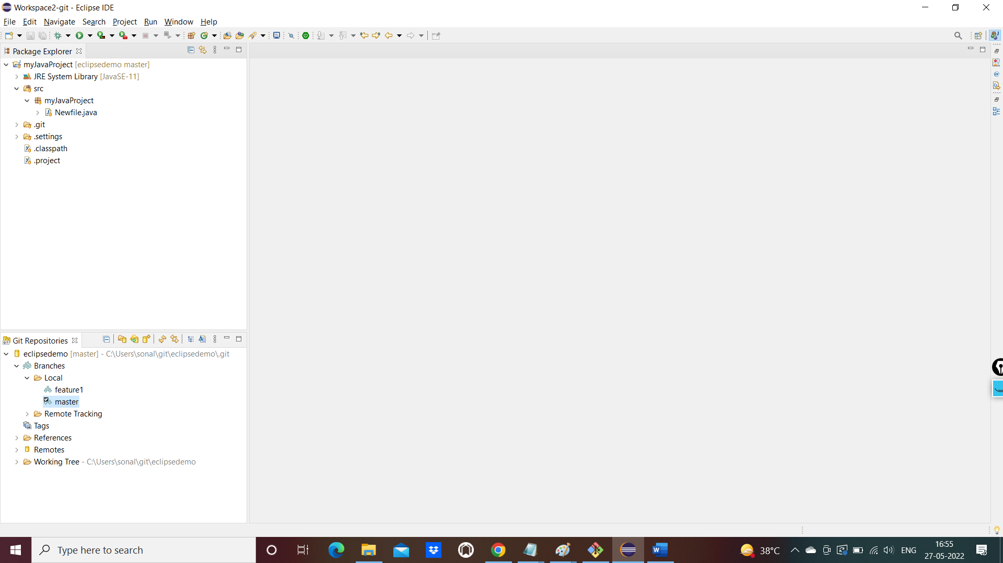

Now switch back to feature branch and push to remote

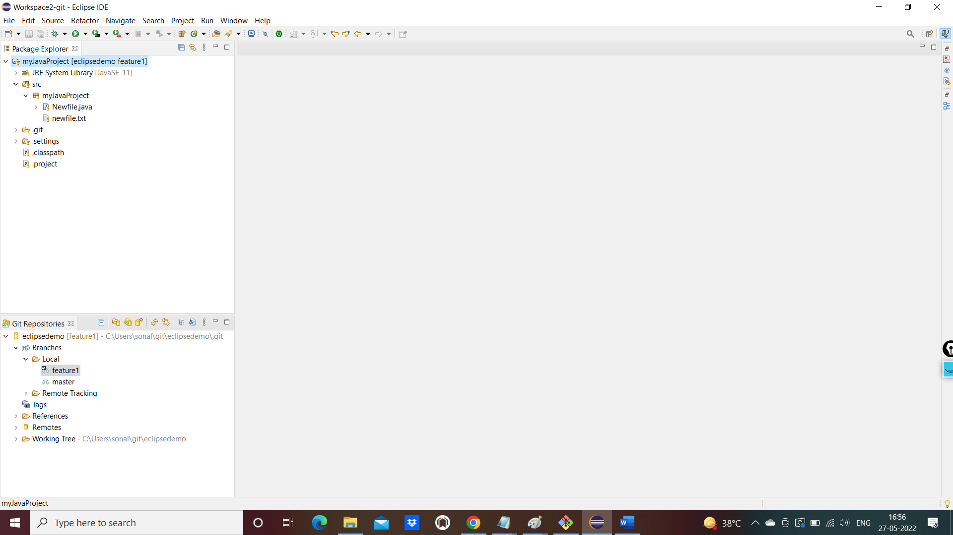

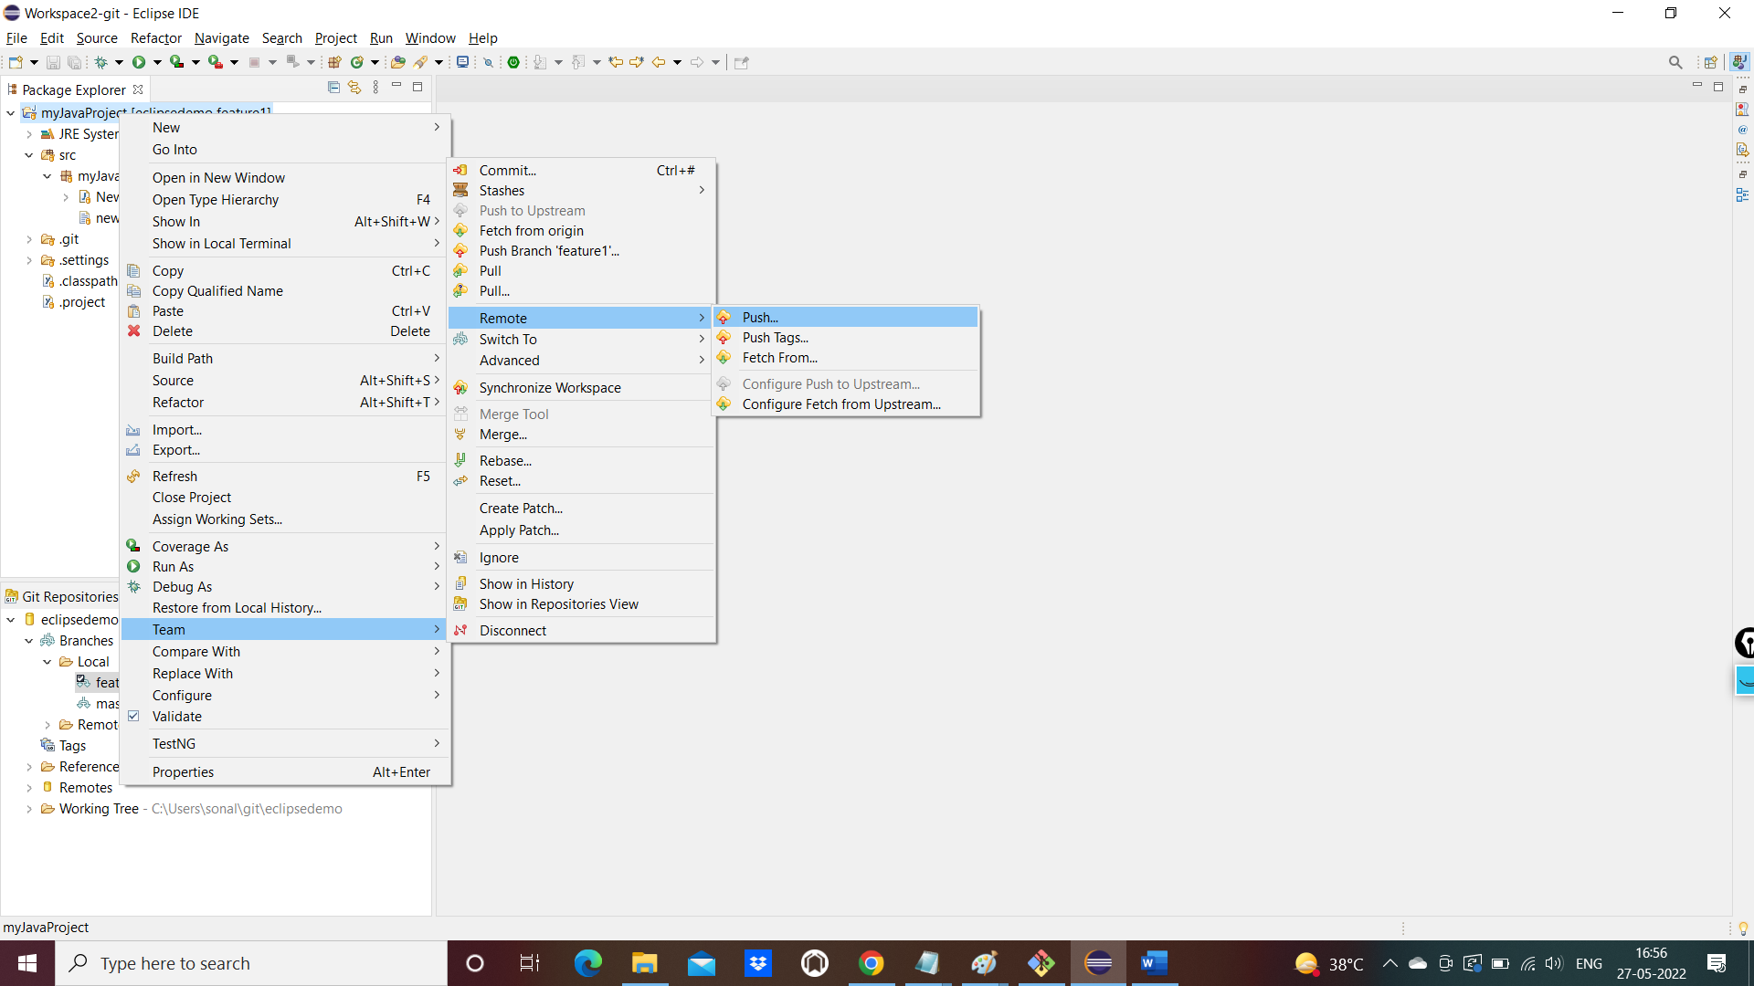

Click on next button and select branch

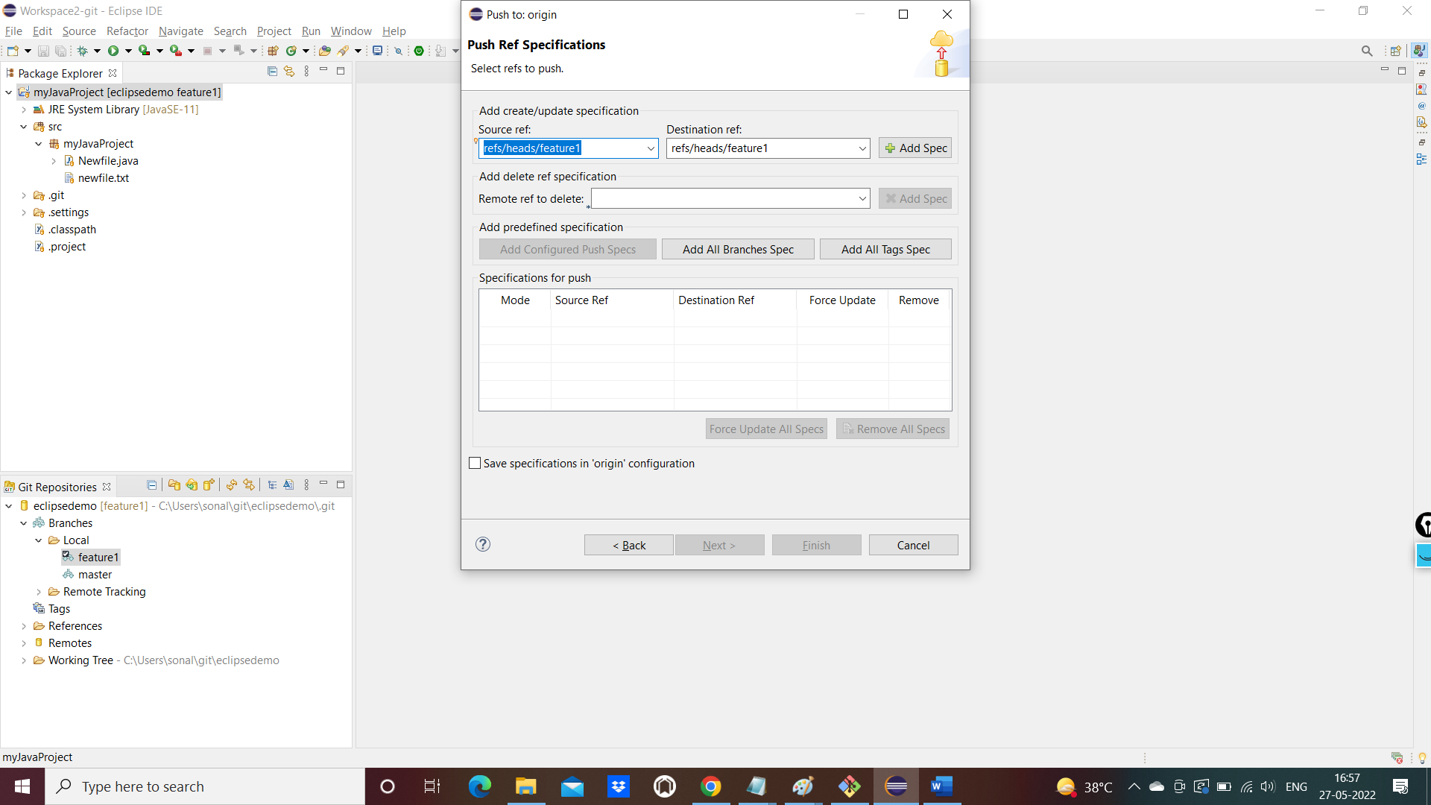

And add to spec

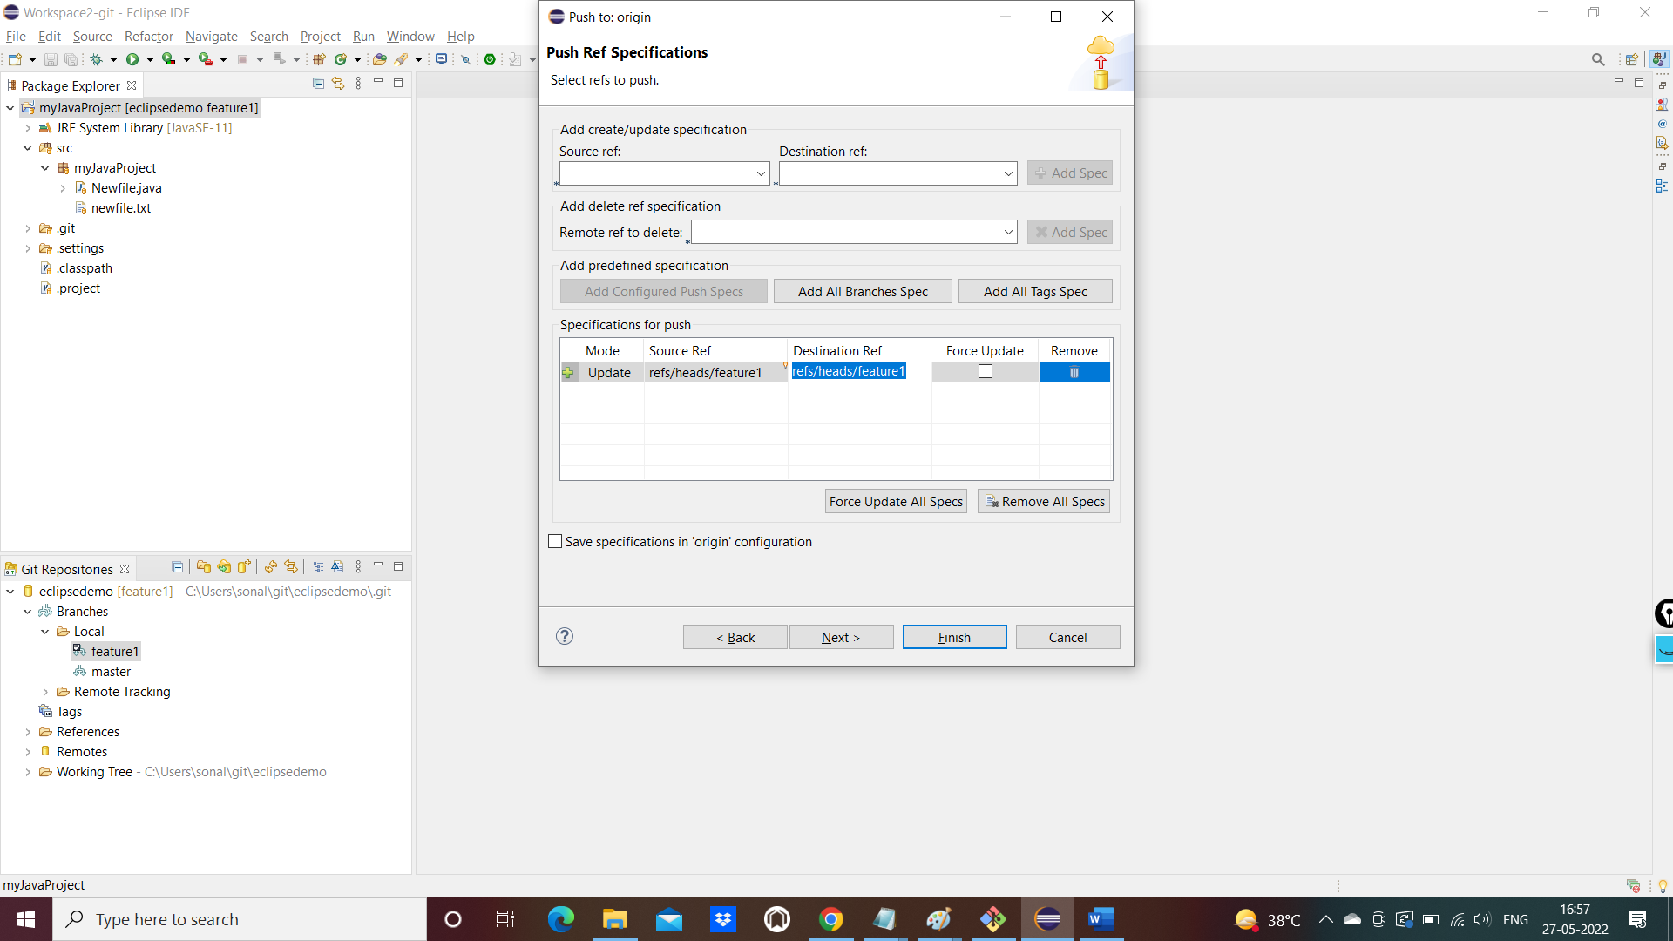

Click on finish button

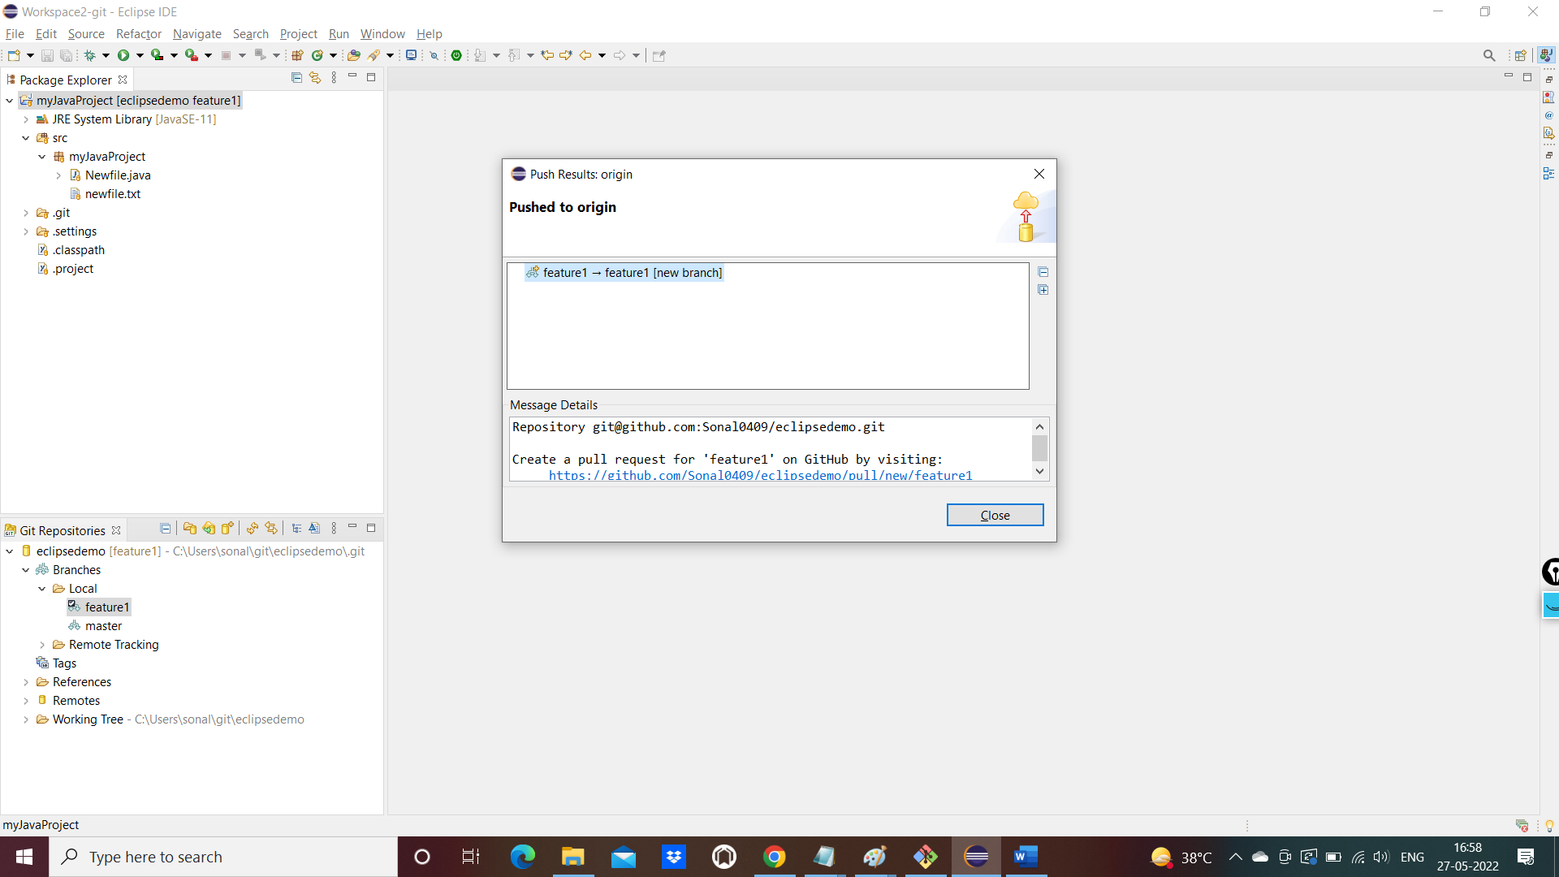

Branch pushed successfully to Remote

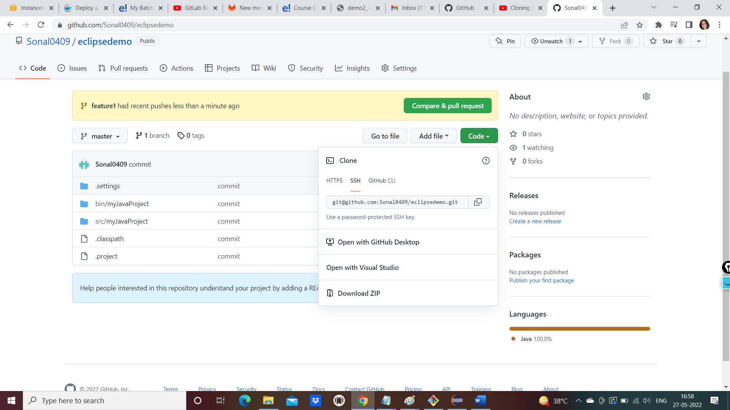

Raise pull request and merge the changes to Master branch